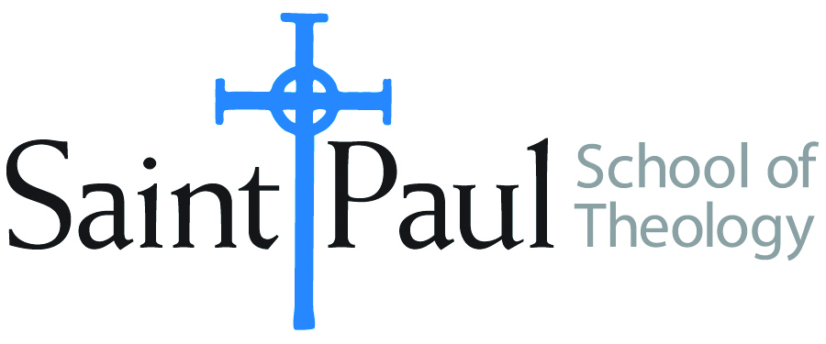
COURSE TEXTBOOK LIST INFORMATION

FACULTY INSTRUCTIONS |  |  | STUDENT INSTRUCTIONS  (Both Campuses)
For each semester taught, faculty should complete and submit a new form each time the course is taught and returned. Forms are due by the first day of registration for a given term.  DESKCOPY – ordered by faculty and adjuncts at a $200 max for 1st time use of text per course. Please fill out an Expense Reimbursement Form, attach all actual/delivered receipts, return via email or mail, and this should be reimbursed with your first stipend payment (or next payroll payment) |  |  | Students may acquire textbooks by ordering online via Amazon or other book retailer and having books shipped to them. Regardless of shopping / ordering method, students may check Cokesbury online for discount on text and certain texts may be sent free delivery.
COURSE INSTRUCTOR(S) | Lisa Wolfe
COURSE NUMBER & SECTION | HBS 301
COURSE NAME | Introduction to the Hebrew Bible
COURSE SEMESTER & YEAR | F2021
DATE OF SUBMISSION | 3/15/21

REQUIRED TEXTBOOKS LIST  BOOK TITLE and EDITION  (include subtitle if applicable) |  | AUTHOR(S) | # of PAGES to be read | PUBLISHER and DATE | 13-Digit ISBN  (without dashes) | LIST PRICE  (est)
1 | A Handbook to Old Testament Exegesis. | Brown, William P. | 340 | Westminster John Knox Press 2007. | 9780664259938 | $25
2 | The Old Testament: A Historical and Literary  Introduction to the Hebrew Scriptures: Fourth Edition. | Coogan, Michael D. and Cynthia R. Chapman. | 608 | Oxford University Press, 2017. | 9780190608651 | $85
3 | ONE of the following scholarly study Bibles (an older version that still contains NRSV is fine):  The New Oxford Annotated Bible, New Revised Standard Version, with the Apocrypha, College Edition (Oxford Press)  OR  The New Interpreter's Study Bible: New Revised Standard Version with the Apocrypha.  (Abingdon Press)  OR  HarperCollins Study Bible: Fully Revised & Updated: New Revised Standard Version: With the Apocryphal Deuterocanonical Books: Student Edition. (HarperCollins) |  |  |  |  | $50
4
5
6
7
8
9
 | TOTAL Number of Pages to Be Read |  | 948

RECOMMENDED TEXTBOOKS LIST  BOOK TITLE and EDITION  (include subtitle if applicable) |  |  | AUTHOR(S) | # of PAGES to be read | PUBLISHER and DATE | 13-Digit ISBN  (without dashes) | LIST PRICE  (est)
1
2
3
4
5
6

