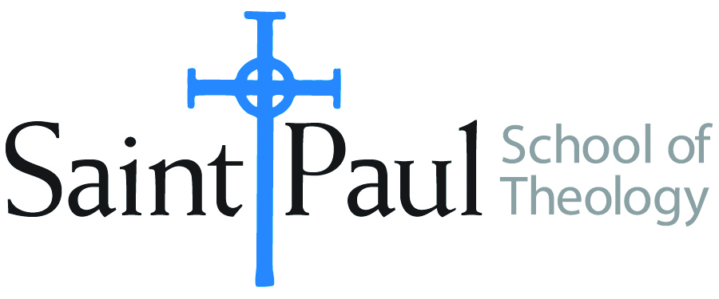
COURSE TEXTBOOK LIST INFORMATION

FACULTY INSTRUCTIONS |  |  | STUDENT INSTRUCTIONS  (Both Campuses)
For each semester taught, faculty should complete and submit a new form each time the course is taught and returned. Forms are due by the first day of registration for a given term.  DESKCOPY – ordered by faculty and adjuncts at a $200 max for 1st time use of text per course. Please fill out an Expense Reimbursement Form, attach all actual/delivered receipts, return via email or mail, and this should be reimbursed with your first stipend payment (or next payroll payment) |  |  | Students may acquire textbooks by ordering online via Amazon or other book retailer and having books shipped to them. Regardless of shopping / ordering method, students may check Cokesbury online for discount on text and certain texts may be sent free delivery.
COURSE INSTRUCTOR(S) | Melissa Tubbs Loya
COURSE NUMBER & SECTION | HBS 301
COURSE NAME | Introduction to the Hebrew Bible
COURSE SEMESTER & YEAR | Fall 2021
DATE OF SUBMISSION | 3.16.21

REQUIRED TEXTBOOKS LIST  BOOK TITLE and EDITION  (include subtitle if applicable) |  | AUTHOR(S) | # of PAGES to be read | PUBLISHER and DATE | 13-Digit ISBN  (without dashes) | LIST PRICE  (est)
1 | The Old Testament  A Historical and Literary Introduction to the Hebrew Scriptures: Fourth Edition | Michael D. Coogan and Cynthia R. Chapman | 608 | Oxford University Press, 2017 | 9780190608651 | $76.95
2 | ONE of the following study Bibles (an older edition of any of these versions is also fine):  The New Oxford Annotated Bible, New Revised Standard Version, with the Apocrypha, College  Edition  OR  The New Interpreter's Study Bible: New Revised Standard Version with the Apocrypha.  Nashville  OR  HarperCollins Study Bible: Fully Revised & Updated: New Revised Standard Version: With the Apocryphal Deuterocanonical Books: Student Edition. | Michael D. Coogan, and Marc Z. Brettler, eds.  Walter J. Harrelson, ed  Edited by Harold W. Attridge | 200 | Oxford University Press, 2010  Abingdon Press, 2003  HarperCollins, 2006 | 9780195289602  9780687278329  9780060786854 | $23.  $30.  $20.
3 | What They Don't Tell You: A Survivor's Guide to Biblical Studies | Michael Joseph Brown | 174 | Westminster John Knox 2000 (the revised version is also acceptable) | 9780664222208 | $4.17 (used on Amazon)
4 | A Handbook to Old Testament Exegesis | William P. Brown | 380 | Westminster John Knox Press 2017 | 9780664259938 | $35
5
6
7
8
9
 | TOTAL Number of Pages to Be Read |  | 1362

RECOMMENDED TEXTBOOKS LIST  BOOK TITLE and EDITION  (include subtitle if applicable) |  |  | AUTHOR(S) | # of PAGES to be read | PUBLISHER and DATE | 13-Digit ISBN  (without dashes) | LIST PRICE  (est)
1
2
3
4
5
6

