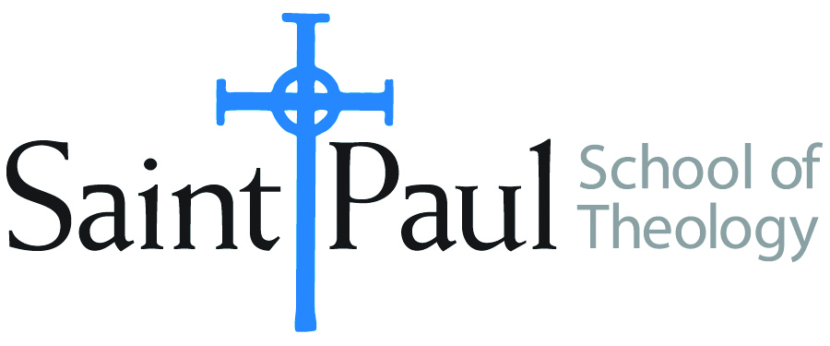
COURSE TEXTBOOK LIST INFORMATION

FACULTY INSTRUCTIONS |  |  | STUDENT INSTRUCTIONS  (Both Campuses)
For each semester taught, faculty should complete and submit a new form each time the course is taught and returned. Forms are due by the first day of registration for a given term.  DESKCOPY – ordered by faculty and adjuncts at a $200 max for 1st time use of text per course. Please fill out an Expense Reimbursement Form, attach all actual/delivered receipts, return via email or mail, and this should be reimbursed with your first stipend payment (or next payroll payment) |  |  | Students may acquire textbooks by ordering online via Amazon or other book retailer and having books shipped to them. Regardless of shopping / ordering method, students may check Cokesbury online for discount on text and certain texts may be sent free delivery.
COURSE INSTRUCTOR(S) | Hal Knight
COURSE NUMBER & SECTION | EVN 311
COURSE NAME | Evangelism Through the Local Church
COURSE SEMESTER & YEAR | Fall 2021
DATE OF SUBMISSION | 3-2-21

REQUIRED TEXTBOOKS LIST  BOOK TITLE and EDITION  (include subtitle if applicable) |  | AUTHOR(S) | # of PAGES to be read | PUBLISHER and DATE | 13-Digit ISBN  (without dashes) | LIST PRICE  (est)
1 | The Logic of Evangelism | William J. Abraham | 233 | Eerdmans, 1989 | 9780802804334 | $23
2 | Biblical Perspectives on Evangelism | Walter Brueggemann | 125 | Abingdon, 1993 | 9780687412334 | $18
3 | The Continuing Conversion of the Church | Darrell L. Guder | 208 | Eerdmans, 2000 | 9780802847034 | $20
4 | Churches that Make a Difference | Ronald J. Sider, et al | 300 | Baker, 2002 | 9780801091339 | $25
5 | A Field Guide to Methodist Fresh Expressions | Michael Adam Beck | 183 | Abingdon, 2020 | 9781501899096 | $14
6 | Unbinding the Gospel (2nd ed.) | Martha Grace Reese | 145 | Chalice Press, 2008 | 9780827238084 | $20
7 | Get Their Name | Bob Farr, et al | 105 | Abingdon, 2013 | 9781426759314 | $13
8 | Transforming Evangelism | Henry H. Knight III & F. Douglas Powe | 94 | Discipleship Resources, 2006 | 9780881774856 | $13
9
 | TOTAL Number of Pages to Be Read |  | 1393

RECOMMENDED TEXTBOOKS LIST  BOOK TITLE and EDITION  (include subtitle if applicable) |  |  | AUTHOR(S) | # of PAGES to be read | PUBLISHER and DATE | 13-Digit ISBN  (without dashes) | LIST PRICE  (est)
1
2
3
4
5
6

