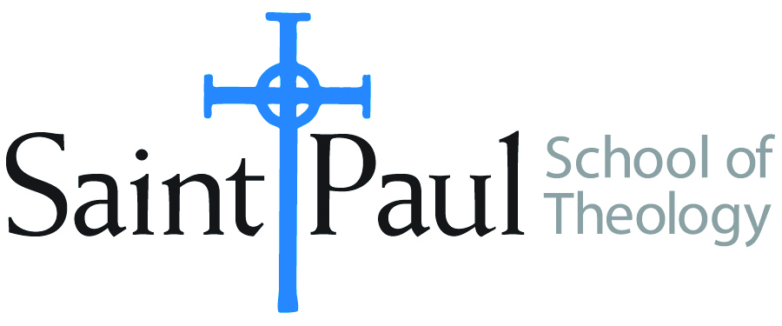
COURSE TEXTBOOK LIST INFORMATION

FACULTY INSTRUCTIONS |  |  | STUDENT INSTRUCTIONS  (Both Campuses)
For each semester taught, faculty should complete and submit a new form each time the course is taught and returned. Forms are due by the first day of registration for a given term.  DESKCOPY – ordered by faculty and adjuncts at a $200 max for 1st time use of text per course. Please fill out an Expense Reimbursement Form, attach all actual/delivered receipts, return via email or mail, and this should be reimbursed with your first stipend payment (or next payroll payment) |  |  | Students may acquire textbooks by ordering online via Amazon or other book retailer and having books shipped to them. Regardless of shopping / ordering method, students may check Cokesbury online for discount on text and certain texts may be sent free delivery.
COURSE INSTRUCTOR(S) | Nancy R. Howell
COURSE NUMBER & SECTION | DMIN 510 HYB
COURSE NAME | Orienting Seminary
COURSE SEMESTER & YEAR | Fall 2021
DATE OF SUBMISSION | March 8, 2021

REQUIRED TEXTBOOKS LIST  BOOK TITLE and EDITION  (include subtitle if applicable) |  | AUTHOR(S) | # of PAGES to be read | PUBLISHER and DATE | 13-Digit ISBN  (without dashes) | LIST PRICE  (est)
1 | Theology and Praxis: Epistemological Foundations | Boff,  Clodovis | 412 | Wipf & Stock,  2009 | 9781608990801 | $52.00
2 | Theological Reflection: Methods, 2nd ed. | Graham,  Elaine et al. | 300 | SCM Press,  2018 | 9780334056119 | $34.00
3 | Quality Research Papers: A Multi-Methods Approach to Projects for Doctor of Ministry Theses | Sensing,  Tim | 100 | Wipf & Stock,  2011 | 9781610972765 | $28.00
4 | A Manual for Writers of Research Papers, Theses, and Dissertations, 9th ed. | Turabian,  Kate L. | 100 | University of Chicago Press,  2018 | 9780226430577 | $15.00
5 | Quality Research Papers: For Students of Religion and Theology, 3rd ed. | Vyhmeiser, Nancy Jean, and  Terry Dwain Robertson | 100 | Zondervan Academic,  2011 | 9780310514022 | $19.00
 | TOTAL Number of Pages to Be Read |  | 1012

RECOMMENDED TEXTBOOKS LIST  BOOK TITLE and EDITION  (include subtitle if applicable) |  |  | AUTHOR(S) | # of PAGES to be read | PUBLISHER and DATE | 13-Digit ISBN  (without dashes) | LIST PRICE  (est)
1 |  | From Topic to Thesis: A Guide to Theological Research | Kibbs,  Michael | n/a | IVP Academic,  2015 | 9780830851317 | $10.00
2 |  | Writing Theology Well: A Rhetoric for Theological and Biblical Writers, 2nd ed. | Yaghjian,  Lucretia B. | n/a | T&T Clark,  2015 | 9780567499172 | $19.00
 |  |  |  | n/a

