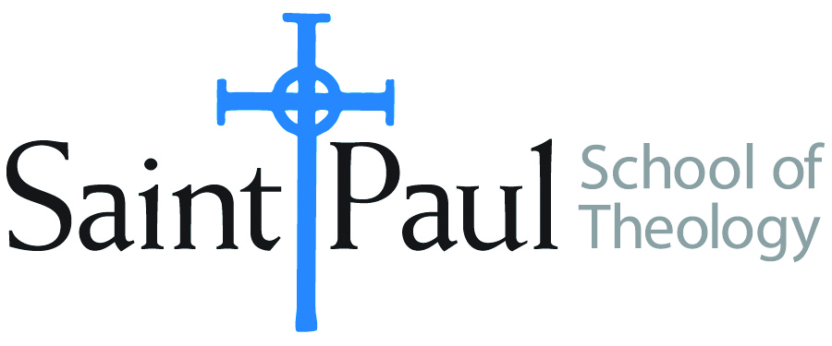
COURSE TEXTBOOK LIST INFORMATION

FACULTY INSTRUCTIONS |  |  | STUDENT INSTRUCTIONS  (Both Campuses)
For each semester taught, faculty should complete and submit a new form each time the course is taught and returned. Forms are due by the first day of registration for a given term.  DESKCOPY – ordered by faculty and adjuncts at a $200 max for 1st time use of text per course. Please fill out an Expense Reimbursement Form, attach all actual/delivered receipts, return via email or mail, and this should be reimbursed with your first stipend payment (or next payroll payment) |  |  | Students may acquire textbooks by ordering online via Amazon or other book retailer and having books shipped to them. Regardless of shopping / ordering method, students may check Cokesbury online for discount on text and certain texts may be sent free delivery.
COURSE INSTRUCTOR(S) | Hal Knight
COURSE NUMBER & SECTION | THL 420
COURSE NAME | The Trinity as Practical Divinity
COURSE SEMESTER & YEAR | Spring, 2021
DATE OF SUBMISSION | 10-6-20

REQUIRED TEXTBOOKS LIST  BOOK TITLE and EDITION  (include subtitle if applicable) |  | AUTHOR(S) | # of PAGES to be read | PUBLISHER and DATE | 13-Digit ISBN  (without dashes) | LIST PRICE  (est)
1 | The Domestication of Transcendence | William C. Placher | 205 | Westminster John Knox | 9780664256357 | $23
2 | Invocation and Assent | Jason E. Vickers | 199 | Eerdmans | 9780802862693 | $22
3 | The Trinitarian Dimensions of John Wesley’s Theology | Elmer M. Colyer | 330 | New Room | 9781945935442 | $36
4 | True Christianity | J. Russell Frazier | 219 | Pickwick | 9781620326633 | $37
5 | Holy Trinity: Holy People | T. A. Noble | 222 | Cascade | 9781620327203 | $22
6
7
 | TOTAL Number of Pages to Be Read |  | 1175

RECOMMENDED TEXTBOOKS LIST  BOOK TITLE and EDITION  (include subtitle if applicable) |  |  | AUTHOR(S) | # of PAGES to be read | PUBLISHER and DATE | 13-Digit ISBN  (without dashes) | LIST PRICE  (est)
1
2
3
4

