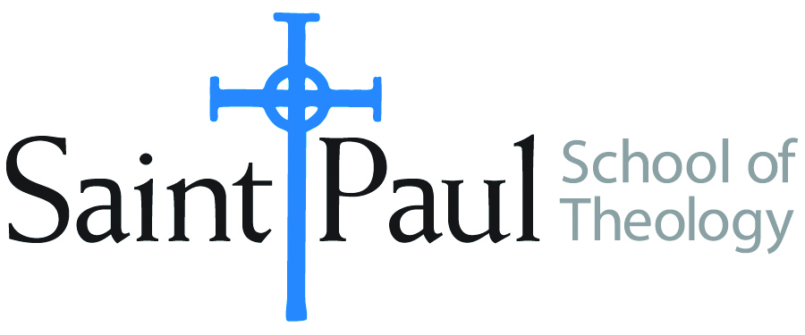
COURSE TEXTBOOK LIST INFORMATION

FACULTY INSTRUCTIONS |  |  | STUDENT INSTRUCTIONS  (Both Campuses)
For each semester taught, faculty should complete and submit a new form each time the course is taught and returned. Forms are due by the first day of registration for a given term.  DESKCOPY – ordered by faculty and adjuncts at a $200 max for 1st time use of text per course. Please fill out an Expense Reimbursement Form, attach all actual/delivered receipts, return via email or mail, and this should be reimbursed with your first stipend payment (or next payroll payment) |  |  | Students may acquire textbooks by ordering online via Amazon or other book retailer and having books shipped to them. Regardless of shopping / ordering method, students may check Cokesbury online for discount on text and certain texts may be sent free delivery.
COURSE INSTRUCTOR(S) | Dr. Kristen E. Kvam
COURSE NUMBER & SECTION | THL 301: all section numbers
COURSE NAME | Introduction to Systematic Thology
COURSE SEMESTER & YEAR | Spring, 2021
DATE OF SUBMISSION | October 16, 2020

REQUIRED TEXTBOOKS LIST  BOOK TITLE and EDITION  (include subtitle if applicable) |  | AUTHOR(S) | # of PAGES to be read | PUBLISHER and DATE | 13-Digit ISBN  (without dashes) | LIST PRICE  (est)
1 | The Humanity of God | Barth, Karl | 90 | Westminster John Knox, 1960 | 9780804206129 | 2.50
2 | Constructive Theology: A Contemporary Approach to Classical Themes | Jones, Serene and Paul Lakeland, ed. | 160 | Fortress Press, 2005 | 9780800636838 | 15.00
3 | Theological Worlds: Understanding the Alternative Rhythms of Christian Belief | Jones, W. Paul | 250 | Abingdon, 1989 | 9780687414703 | 2.00
4 | Why Study Theology? | Luck, Donald | 150 | Chalice, 1999 | 9780226803418 | 1.00
5 | Belonging to God: A Commentary on a Brief Statement of Faith | Placher, William, and David Willis-Watkins | 200 | Westminster John Knox, 1992 | 8780664252960 | 1.00
6 | Awake to the Moment: An Introduction to Theology | Schneider, Laurel, and Stephen G. Ray, Jr., ed. | 250 | Westminster John Knox, | 9780664261887 | 16.00
7 | Biblical Religion and the Search for Ultimate Reality | Tillich, Paul | 90 | University of Chicago Press, 1964 | 9780226803418 | 3.00
 | TOTAL Number of Pages to Be Read |  | 1200

RECOMMENDED TEXTBOOKS LIST  BOOK TITLE and EDITION  (include subtitle if applicable) | AUTHOR(S) | # of PAGES | PUBLISHER and DATE | 13-Digit ISBN  (without dashes) | LIST PRICE  (est)
BOOK TITLE and EDITION  (include subtitle if applicable) |  | AUTHOR(S) | No. of  PAGES to be read | PUBLISHER and DATE | 13-Digit ISBN  (without dashes) | LIST PRICE  (estimate) | DESK COPY
1 | Christian Confessions: A Historical Introduction | Campbell, Ted A. |  | Westminster John Knox, 1996 | 9780664256500 | 9.97 | no
2 | Christian Thought Revisited: Three Types of Theology | Gonzalez, Justo |  | Orbis, 1999 | 978170752551 | 9.97 | no
3 | Christian Doctrine, Revised Ed. | Guthrie, Shirley |  | Westminster John Knox, 1994 | 9780664253684 | 0.49 | no
4 | Readings in Christian Theology | Hodgson, Peter, and Robert King, ed. |  | Fortress, 1985 | 9780800618490 | 2.34 | no
5 | Quest for the Living God | Johnson, Elizabeth |  | Bloomsbury Academic, 2007 | 9780826417701 | 3.55 | no
6 | Worlds Within a Congregation: Dealing with Theological Diversity | Jones, W. Paul |  | Abingdon Press, 2000 | 9780687084340 | 11.59 | no
7 | The Concise Oxford Dictionary of the Christian Church | Livingston, E. A., ed. |  | Oxford University Pres, 2913 | 9780199659623 | 11.00
8 | Dictionary of the Ecumenical Movement. 1st or 2d Edition | Lossky, Nicholas, et. |  | Eerdmanns | varies | varies
9 | Westminster Dictionary of Theological Terms, 2d edition, rev. | McKim, Donald I. |  | Wetminster John Knox, 2014. | Pbk: 9780664238353 | 22.00
10 | New and Enlarged Handbook of Christian Theological | Musser, Donald, and Joseph Price |  | Abingdon, 2003 | 9780687091126 | 21.00 | no
11 | Dictionary of Feminist Theologies | Russell, Letty, and Clarkson, J. Shannon |  | Westminster John Knox, 1996 | 9780664220587 | 3.94 | No
12 | A Manual for Writers of Research Papers, Theses, and Dissertations, a recent edition | Turabian, Kate L., et alia |  | University of Chicago Press, | 9780226430577

SPECIAL INSTRUCTIONS: Kris Kvam will describe her reasons for recommending the foregoing texts so Students may want to wait to purchase from the Recommended list until They have Heard Kvam’s descriptions.

