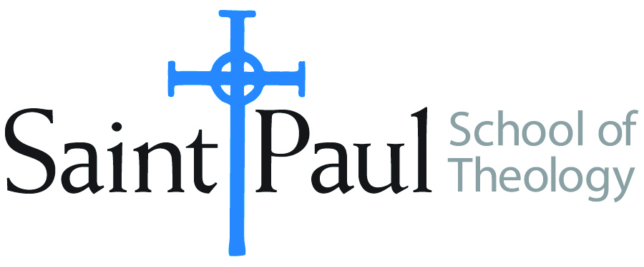
COURSE TEXTBOOK LIST INFORMATION

FACULTY INSTRUCTIONS |  |  | STUDENT INSTRUCTIONS  (Both Campuses)
For each semester taught, faculty should complete and submit a new form each time the course is taught and returned. Forms are due by the first day of registration for a given term.  DESKCOPY – ordered by faculty and adjuncts at a $200 max for 1st time use of text per course. Please fill out an Expense Reimbursement Form, attach all actual/delivered receipts, return via email or mail, and this should be reimbursed with your first stipend payment (or next payroll payment) |  |  | Students may acquire textbooks by ordering online via Amazon or other book retailer and having books shipped to them. Regardless of shopping / ordering method, students may check Cokesbury online for discount on text and certain texts may be sent free delivery.
COURSE INSTRUCTOR(S) | Sharon Betsworth
COURSE NUMBER & SECTION | NTS 321
COURSE NAME | New Testament Greek II
COURSE SEMESTER & YEAR | Spring 2021
DATE OF SUBMISSION | 10/9/20

REQUIRED TEXTBOOKS LIST  BOOK TITLE and EDITION  (include subtitle if applicable) |  | AUTHOR(S) | # of PAGES to be read | PUBLISHER and DATE | 13-Digit ISBN  (without dashes) | LIST PRICE  (est)
1 | Basics of Biblical Greek: Grammar | William D. Mounce | 350 | Zondervan, 2019 | 9780310537441 | $35
2 | Basics of Biblical Greek: Workbook | William D. Mounce | 200 | Zondervan, 2019 | 978031053748 | $17
3 | Deeper than Words: Living the Apostle's Creed | Bro. David Steindl-Rast | 175 | Doubleday, 2010 | 9780307589613 | $12
4
5
6
7
 | TOTAL Number of Pages to Be Read

RECOMMENDED TEXTBOOKS LIST  BOOK TITLE and EDITION  (include subtitle if applicable) |  |  | AUTHOR(S) | # of PAGES to be read | PUBLISHER and DATE | 13-Digit ISBN  (without dashes) | LIST PRICE  (est)
1 |  | Read it in Greek: | William L. Countryman | 100 | Eerdmans, 1993 | 9780802806659 | $16
2 |  | The Greek New Testament | United Bible Society |  | Deutsche Biblegesellschaft | 9783438051103 | $45
3
4

