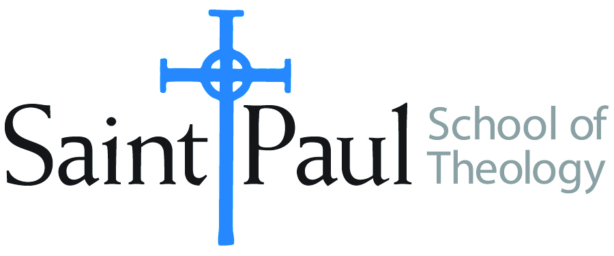
COURSE TEXTBOOK LIST INFORMATION

FACULTY INSTRUCTIONS |  |  | STUDENT INSTRUCTIONS (Both Campuses)
For each semester taught, faculty should complete and submit a new form for every course and return to Joshua Farrell in the Academic Life office. The due dates are September 1 for the following Spring and Summer, and February 1 for the following Fall and Winter. If books are needed in the bookstore at an earlier date than normal, please give exact date in the “Special Instructions” section. Due to limited space, Cokesbury may only have books on hand for the current and upcoming semesters. Desk copies for Teaching Assistants must be requested on this form. It is up to the publishers’ discretion whether or not to provide desk copies for teaching assistants. |  |  | Students may acquire textbooks by shopping at their campus Cokesbury store (in person, by email, or by fax), or by ordering online at the Cokesbury Virtual Bookstore and having books shipped to them. Regardless of shopping/ordering method, students may be eligible for a clergy discount by ordering through Cokesbury! Abingdon Press textbook titles are 35% off in the store.  Textbook lists will be available online at http://www.spst.edu/registrar/coursematerial
COURSE INSTRUCTOR(S) | Israel Kamudzandu
COURSE NUMBER & SECTION | NTS 301 On Campus and Online
COURSE NAME | NTS: Introduction to New Testament
COURSE SEMESTER &YEAR | Spring 2021
DATE OF SUBMISSION | 10/09/20

REQUIRED TEXTBOOKS LIST
BOOK TITLE and EDITION  (include subtitle if applicable) |  | AUTHOR(S) | No. of  PAGES to be read | PUBLISHER and DATE | 13-Digit ISBN  (without dashes) | LIST PRICE  (estimate) | DESK COPY
1 | The Writings of the New Testament | Luke Timothy Johnson | 563 | Minneapolis: Fortress Press, 2010 | 97808006-63612 | $ 22.49
2 | Elements of Biblical Exegesis: A Basic Guide for Students and Ministers | Michael J. Gorman | 280 | Peabody, Massachusetts: Hendrickson Publishers, 2009 | 9780801046407 | $30.00 | 1
3 | Gospel Parallels: A Comparison | Burton Throckmorton, Jr | 400 | Thomas Nelson Publishing 1992 | 9780195284782 | $34.00
5
6
 | TOTAL Number of Pages to Be Read |  | 1243

RECOMMENDED TEXTBOOKS LIST
BOOK TITLE and EDITION  (include subtitle if applicable) |  | AUTHOR(S) | No. of  PAGES to be read | PUBLISHER and DATE | 13-Digit ISBN  (without dashes) | LIST PRICE  (estimate) | DESK COPIES
1 |  |  |  |  |  | $
 | TOTAL Number of Pages to Be Read |  | 1243
Synopsis of the four Gospels maybe Replaced by Cheaper versions of the Synopsis.
Special Instructions from Faculty to Students: Amazon has Cheap Used Books and there are other half Price Book Stores selling these Books Cheaper.
Note: For Bibles, I Recommend the following:
The New Oxford Annotated Bible: New York: Oxford University Press, but there are a variety of these and any version you buy will be good for the Course.

