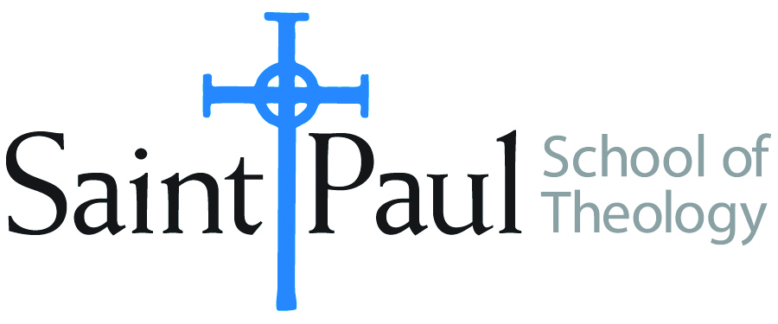
COURSE TEXTBOOK LIST INFORMATION

FACULTY INSTRUCTIONS |  |  | STUDENT INSTRUCTIONS  (Both Campuses)
For each semester taught, faculty should complete and submit a new form each time the course is taught and returned. Forms are due by the first day of registration for a given term.  DESKCOPY – ordered by faculty and adjuncts at a $200 max for 1st time use of text per course. Please fill out an Expense Reimbursement Form, attach all actual/delivered receipts, return via email or mail, and this should be reimbursed with your first stipend payment (or next payroll payment) |  |  | Students may acquire textbooks by ordering online via Amazon or other book retailer and having books shipped to them. Regardless of shopping / ordering method, students may check Cokesbury online for discount on text and certain texts may be sent free delivery.
COURSE INSTRUCTOR(S) | Dr. Kristen E. Kvam
COURSE NUMBER & SECTION | MIN 340 and MIN 341
COURSE NAME | Women, Society, and Church Studies Seminar
COURSE SEMESTER & YEAR | Spring 2021
DATE OF SUBMISSION | October 16, 2020

REQUIRED TEXTBOOKS LIST  BOOK TITLE and EDITION  (include subtitle if applicable) |  | AUTHOR(S) | # of PAGES to be read | PUBLISHER and DATE | 13-Digit ISBN  (without dashes) | LIST PRICE  (est)
1 | Hope Abundant: Third World and Indigenous Women’s Theology | Kwok Pui-Lan | 270 | Orbis Books, 2010. | 9781570758805 | 24.00
2
3
4
5
 | TOTAL Number of Pages to Be Read |  | 270

RECOMMENDED TEXTBOOKS LIST  BOOK TITLE and EDITION  (include subtitle if applicable) |  |  | AUTHOR(S) | # of PAGES to be read | PUBLISHER and DATE | 13-Digit ISBN  (without dashes) | LIST PRICE  (est)
1 |  | Dictionary of Feminist Theologies | Russell, Letty, and Clarkson, J. Shannon |  | Westminster John Knox, 1996 | 9780664220587 | 3.94 | No
2 |  | A Manual for Writers of Research Papers, Theses, and Dissertations, a recent edition | Turabian, Kate L., et alia |  | University of Chicago Press, | 9780226430577
3
4

