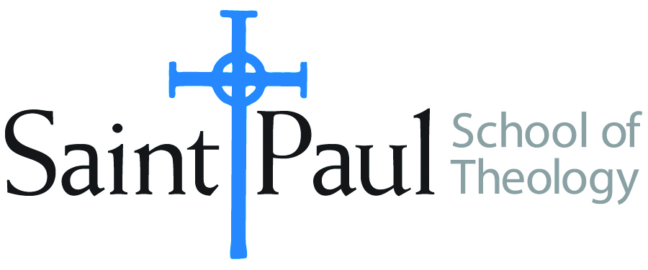
COURSE TEXTBOOK LIST INFORMATION

FACULTY INSTRUCTIONS |  |  | STUDENT INSTRUCTIONS  (Both Campuses)
For each semester taught, faculty should complete and submit a new form each time the course is taught and returned. Forms are due by the first day of registration for a given term.  DESKCOPY – ordered by faculty and adjuncts at a $200 max for 1st time use of text per course. Please fill out an Expense Reimbursement Form, attach all actual/delivered receipts, return via email or mail, and this should be reimbursed with your first stipend payment (or next payroll payment) |  |  | Students may acquire textbooks by ordering online via Amazon or other book retailer and having books shipped to them. Regardless of shopping / ordering method, students may check Cokesbury online for discount on text and certain texts may be sent free delivery.
COURSE INSTRUCTOR(S) | Oden
COURSE NUMBER & SECTION | HST 454
COURSE NAME | Seminar in Historical Studies: Women in Christianity
COURSE SEMESTER & YEAR | Spring 2021
DATE OF SUBMISSION | October 17, 2020

REQUIRED TEXTBOOKS LIST  BOOK TITLE and EDITION  (include subtitle if applicable) |  | AUTHOR(S) | # of PAGES to be read | PUBLISHER and DATE | 13-Digit ISBN  (without dashes) | LIST PRICE  (est)
1 | In Her Words | Amy Oden | 350 | Abingdon, 1994 | 9780687459728 | 25.00
2 | HerStory, 2nd edition | Barbara MacHaffie | 350 | Fortress, 2006 | 9780800638269 | 44.00
3 | The Forgotten Desert Mothers | Laura Swan | 200 | Paulist, 2001 | 9780809140169 | 14.00
4 | Medieval Women’s Visionary Literature | Elizabeth Petroff | 370 | Oxford, 1986 | 9780195037128 | 40.00
5 | Other articles assigned as pdfs |  | 60
6 | A Woman’s Place | Carolyn Osiek, Margaret McDonald | 350 | Fortress, 2005 | 9780800637774 | 24.00
7
 | TOTAL Number of Pages to Be Read |  | 1680

RECOMMENDED TEXTBOOKS LIST  BOOK TITLE and EDITION  (include subtitle if applicable) |  |  | AUTHOR(S) | # of PAGES to be read | PUBLISHER and DATE | 13-Digit ISBN  (without dashes) | LIST PRICE  (est)
1
2
3
4

