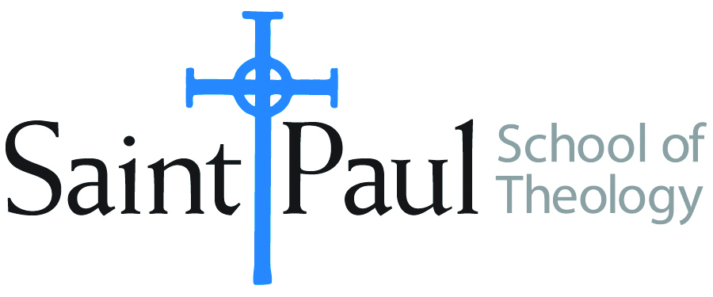
COURSE TEXTBOOK LIST INFORMATION

FACULTY INSTRUCTIONS |  |  | STUDENT INSTRUCTIONS  (Both Campuses)
For each semester taught, faculty should complete and submit a new form for every course and returned, even if no desk copies are needed, just type “none”. Forms are due by the first day of registration for a given term. Desk copies for Teaching Assistants must be requested on this form, if needed. |  |  | Students may acquire textbooks by ordering online via Amazon or other book retailer and having books shipped to them. Regardless of shopping/ordering method, students may check Cokesbury online for discount on text and certain text may be sent free delivery.
COURSE INSTRUCTOR(S)
COURSE NUMBER & SECTION | DMin 540 ON; DMin 552 ON; DMin 561 ON; DMin 562 ON; DMin 563 ON
COURSE NAME | Praxis Thesis Evaluation Proposal Writing Conference
COURSE SEMESTER & YEAR | Spring 2021
DATE OF SUBMISSION

REQUIRED TEXTBOOKS LIST
BOOK TITLE and EDITION  (include subtitle if applicable) | AUTHOR(S) | # of PAGES to be read | PUBLISHER and DATE | 13-Digit ISBN  (without dashes) | LIST PRICE  (est) | DESK COPY

The Dmin DO NOT HAVE REQUIRED BOOKS

