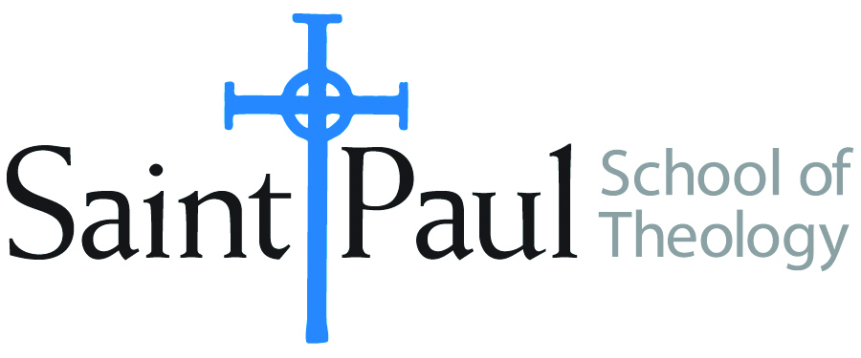
COURSE TEXTBOOK LIST INFORMATION

FACULTY INSTRUCTIONS |  |  | STUDENT INSTRUCTIONS  (Both Campuses)
For each semester taught, faculty should complete and submit a new form each time the course is taught and returned. Forms are due by the first day of registration for a given term.  DESKCOPY – ordered by faculty and adjuncts at a $200 max for 1st time use of text per course. Please fill out an Expense Reimbursement Form, attach all actual/delivered receipts, return via email or mail, and this should be reimbursed with your first stipend payment (or next payroll payment) |  |  | Students may acquire textbooks by ordering online via Amazon or other book retailer and having books shipped to them. Regardless of shopping / ordering method, students may check Cokesbury online for discount on text and certain texts may be sent free delivery.
COURSE INSTRUCTOR(S) | Rev. Dr. Katie Nix
COURSE NUMBER & SECTION | CHS 330
COURSE NAME | “Mission of the Church in the Contemporary World”
COURSE SEMESTER & YEAR | Spring 2021
DATE OF SUBMISSION | October 6, 2020

REQUIRED TEXTBOOKS LIST  BOOK TITLE and EDITION  (include subtitle if applicable) |  | AUTHOR(S) | # of PAGES to be read | PUBLISHER and DATE | 13-Digit ISBN  (without dashes) | LIST PRICE  (est)
1 | When Helping Hurts: How to Alleviate Poverty Without Hurting the Poor…and Yourself | Corbett, Steve and Brian Fikkert |  | Chicago: Moody Publishers, 2012
2 | Churches, Cultures, and Leadership | Branson, Mark and Juan Martínez |  | Downers Grove, IL: InterVarsity Press, 2011
3 | Deep Justice in a Broken World | Powell, Kara and Chap Clark |  | Grand Rapids, MI: Zondervan, 2007
4 | The Book of Discipline of the United Methodist Church | United Methodist Church
5 | Be My Witnesses | Guder, Darrell |  | Grand Rapids, MI: William B. Eerdmans Publishing  Company, 1985
6 | The Open Secret: An Introduction to the Theology of Mission | Newbigin, Lesslie |  | Grand Rapids, MI: William B. Eerdmans Publishing Company, 1995
7 | Faithful Presence: Seven Disciplines That Shape the Church for Mission. | Fitch, David |  | Downers Grove, IL: InterVarsity Press, 2016
 | TOTAL Number of Pages to Be Read

Continued Required Reading List  BOOK TITLE and EDITION  (include subtitle if applicable) |  |  | AUTHOR(S) | # of PAGES to be read | PUBLISHER and DATE | 13-Digit ISBN  (without dashes) | LIST PRICE  (est)
8 |  | The Dangerous Act of Worship | Labberton, Mark |  | Downers Grove, IL: InterVarsity Press, 2007
9 |  | Parenting Forward: How to Raise Children with Justice, Mercy, and Kindness | Brandt, Cindy Want |  | Grand Rapids, MI: William B. Eerdmans Publishing Company, 2019
10 |  | Mission-Minded Guide to Church and School Partnerships | McGlothin, Jake |  | Nashville, TN: Abindgon Press, 2017
11

