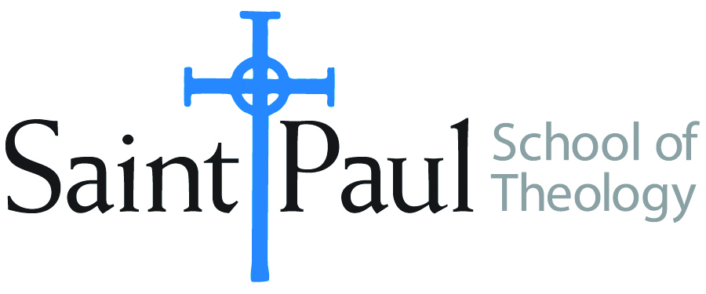
COURSE TEXTBOOK LIST INFORMATION

FACULTY INSTRUCTIONS |  |  | STUDENT INSTRUCTIONS  (Both Campuses)
For each semester taught, faculty should complete and submit a new form for every course and return to . Forms are due by the first day of registration for a given term. Desk copies for Teaching Assistants must be requested on this form. It is up to the publishers’ discretion whether or not to provide desk copies for teaching assistants. |  |  | Students may acquire textbooks by ordering online via Amazon Associate on our website and having books shipped to them. Regardless of shopping/ordering method, students may check Cokesbury online for discount on text and certain text may be sent free delivery.
COURSE INSTRUCTOR(S) | Elaine Robinson
COURSE NUMBER & SECTION | CHL422 AKV and AOV
COURSE NAME | Leading the Multi-Ethnic Church
COURSE SEMESTER &YEAR | Spring 2021
DATE OF SUBMISSION | October 11, 2020

REQUIRED TEXTBOOKS LIST
BOOK TITLE and EDITION  (include subtitle if applicable) |  | AUTHOR(S) | No. of  PAGES to be read | PUBLISHER and DATE | 13-Digit ISBN  (without dashes) | LIST PRICE  (estimate) | DESK COPY
1 | Building a Healthy Multi-  Ethnic Church | DeYmaz, Mark | 184 | John Wiley & Sons,2007 | 9780787995515 | $20
2 | Biased | Eberhardt,  Jennifer | 250 | Penguin, 2020 | 9780735224957 | $14
3 | Church Leadership | Weems, Lovett | 168 | Abingdon Press, 2010 | 9781426703027 | $18
4 | Intercultural Church | Marzouk | 212 | Fortress, 2019 | 9781506433462 | $16
5
6
7
 | TOTAL Number of Pages to Be Read |  | 600

RECOMMENDED TEXTBOOKS LIST
BOOK TITLE and EDITION  (include subtitle if applicable) |  | AUTHOR(S) | No. of  PAGES to be read | PUBLISHER and DATE | 13-Digit ISBN  (without dashes) | LIST PRICE  (estimate) | DESK COPY
1
2
3
4

Special Instructions to Cokesbury:

