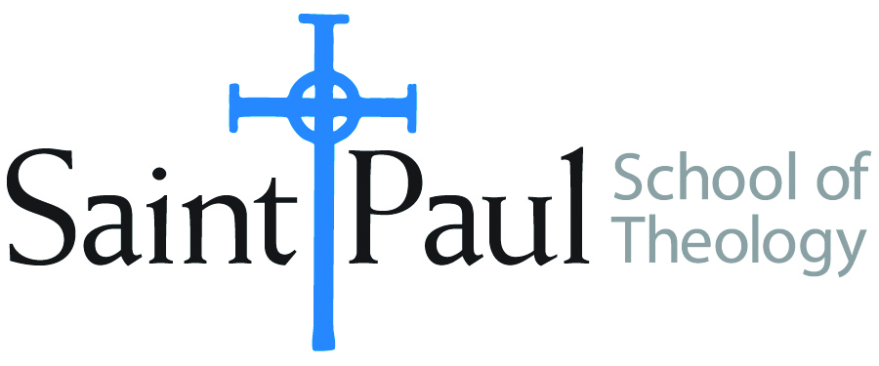
COURSE TEXTBOOK LIST INFORMATION

FACULTY INSTRUCTIONS |  |  | STUDENT INSTRUCTIONS  (Both Campuses)
For each semester taught, faculty should complete and submit a new form each time the course is taught and returned. Forms are due by the first day of registration for a given term.  DESKCOPY – ordered by faculty and adjuncts at a $200 max for 1st time use of text per course. Please fill out an Expense Reimbursement Form, attach all actual/delivered receipts, return via email or mail, and this should be reimbursed with your first stipend payment (or next payroll payment) |  |  | Students may acquire textbooks by ordering online via Amazon or other book retailer and having books shipped to them. Regardless of shopping / ordering method, students may check Cokesbury online for discount on text and certain texts may be sent free delivery.
COURSE INSTRUCTOR(S) | Laurie Anderson
COURSE NUMBER & SECTION | PCM 317 AK
COURSE NAME | Immigration Justice Advocacy
COURSE SEMESTER & YEAR | Fall 2020
DATE OF SUBMISSION | 3/17/20

REQUIRED TEXTBOOKS LIST  BOOK TITLE and EDITION  (include subtitle if applicable) |  | AUTHOR(S) | # of PAGES to be read | PUBLISHER and DATE | 13-Digit ISBN  (without dashes) | LIST PRICE  (est)
1 | VARIOUS ARTICLES FOR READING WILL BE POSTED WITHIN THE COMING WEEKS.
2 | Tell Me How it Ends (an essay in forty questions) by Valeria Luiselli
3 | Toolkit for Faith Communities to Accompany People Seeking Asylum https://www.sanctuarynotdeportation.org/uploads/7/6/9/1/76912017/asylum_seeker_accompaniment_toolkit_for_interior_congregations__1_.pdf
4 | Sanctuary Toolkit (2017)  https://www.sanctuarynotdeportation.org/uploads/7/6/9/1/76912017/interfaith_sanctuary_toolkit.pdf
 | TOTAL Number of Pages to Be Read

