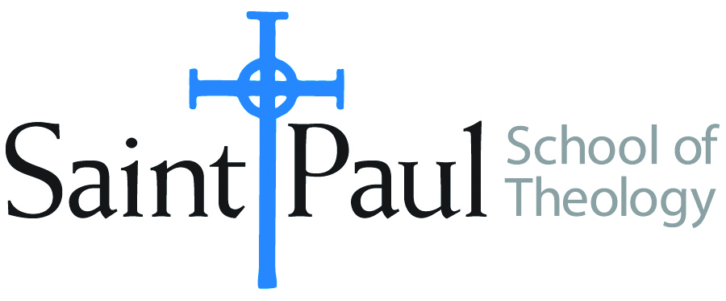
COURSE TEXTBOOK LIST INFORMATION

FACULTY INSTRUCTIONS |  |  | STUDENT INSTRUCTIONS  (Both Campuses)
For each semester taught, faculty should complete and submit a new form each time the course is taught and returned. Forms are due by the first day of registration for a given term.  DESKCOPY – ordered by faculty and adjuncts at a $200 max for 1st time use of text per course. Please fill out an Expense Reimbursement Form, attach all actual/delivered receipts, return via email or mail, and this should be reimbursed with your first stipend payment (or next payroll payment) |  |  | Students may acquire textbooks by ordering online via Amazon or other book retailer and having books shipped to them. Regardless of shopping / ordering method, students may check Cokesbury online for discount on text and certain texts may be sent free delivery.
COURSE INSTRUCTOR(S) | Dr. Imad Enchassi
COURSE NUMBER & SECTION | EWR 312
COURSE NAME | Engaging World Religions: Islam
COURSE SEMESTER & YEAR | FA 2020
DATE OF SUBMISSION | 6-16-2020

REQUIRED TEXTBOOKS LIST  BOOK TITLE and EDITION  (include subtitle if applicable) |  | AUTHOR(S) | # of PAGES to be read | PUBLISHER and DATE | 13-Digit ISBN  (without dashes) | LIST PRICE  (est)
1 | Islam: The Straight Path | John L. Esposito |  | Oxford University Press  (4th Ed. 2010) | 978-0195396003 | $23
2 | What Everyone Needs to Know About Islam | John L. Esposito |  | Oxford University Press  (2nd Ed. 2011) | 978-0199794133 | $14
3 | Understand Islam: A Guide for the Judeo-Christian Reader | Jerald Dirks |  | Amana Pubns  (1st Ed. 2003). | 978-1590080214 | $19
4
5
6
7
 | TOTAL Number of Pages to Be Read

RECOMMENDED TEXTBOOKS LIST  BOOK TITLE and EDITION  (include subtitle if applicable) |  |  | AUTHOR(S) | # of PAGES to be read | PUBLISHER and DATE | 13-Digit ISBN  (without dashes) | LIST PRICE  (est)
1
2
3
4

