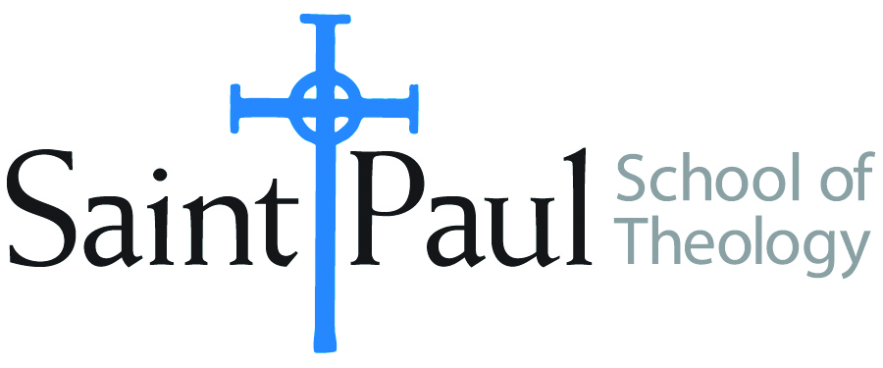
COURSE TEXTBOOK LIST INFORMATION

FACULTY INSTRUCTIONS |  |  | STUDENT INSTRUCTIONS  (Both Campuses)
For each semester taught, faculty should complete and submit a new form each time the course is taught and returned. Forms are due by the first day of registration for a given term.  DESKCOPY – ordered by faculty and adjuncts at a $200 max for 1st time use of text per course. Please fill out an Expense Reimbursement Form, attach all actual/delivered receipts, return via email or mail, and this should be reimbursed with your first stipend payment (or next payroll payment) |  |  | Students may acquire textbooks by ordering online via Amazon or other book retailer and having books shipped to them. Regardless of shopping / ordering method, students may check Cokesbury online for discount on text and certain texts may be sent free delivery.
COURSE INSTRUCTOR(S) | James Brandt
COURSE NUMBER & SECTION | CHL 520
COURSE NAME | Becoming Agents of God’s Hope
COURSE SEMESTER & YEAR | Fall 2020
DATE OF SUBMISSION | April 9, 2020 (rev. June 3, 2020)

REQUIRED TEXTBOOKS LIST  BOOK TITLE and EDITION  (include subtitle if applicable) |  | AUTHOR(S) | # of PAGES to be read | PUBLISHER and DATE | 13-Digit ISBN  (without dashes) | LIST PRICE  (est)
1 | Moral Leadership for a Divided Age | David P. Gushee & Colin Holtx | 367 | Brazos Press, 2018 | 9781587433573 | $25
2 | Memories, Hopes & Conversations | Mark Lau Branson | 286 | Rowman & Littlefield, 2nd ed, 2016 | 9781566997836 | $27
3 | Uproar: Calm Leadership in Anxious Times | Peter Steinke | 176 | Rowman & Littlefield, 2018 | 9781538116531 | $16
4 | How to Lead When You Don’t Know Where you are Going | Susan Beaumont | 184 | Rowman & Littlefield, New edition, 2019 | 9781538127681 | $28
5 | The Fierce Urgency of Prophetic Hope | Wendell L.Griffen | 160 | Judson Press, 2017 | 9780817017866 | $20
6 | Sustaining Hope in an Unjust World | Timothy Charles Murphy | 128 | Christian Board of Discipleship, 2019 | 9780827235434 | $17
7 | The Power of Love | Michael Curry | 112 | Penguin, 2018 | 9780525542896 | $20
 | TOTAL Number of Pages to Be Read |  | 1413

RECOMMENDED TEXTBOOKS LIST  BOOK TITLE and EDITION  (include subtitle if applicable) |  | AUTHOR(S) | # of PAGES to be read | PUBLISHER and DATE | 13-Digit ISBN  (without dashes) | LIST PRICE  (est)
1

