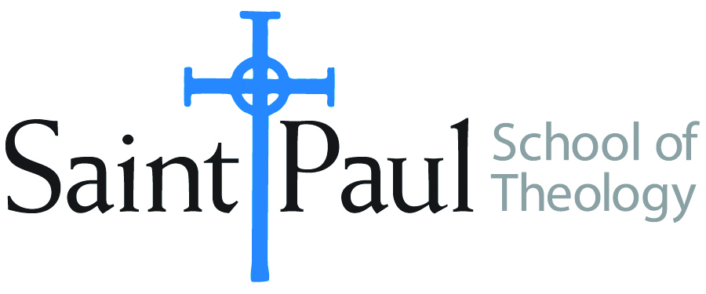
COURSE TEXTBOOK LIST INFORMATION
FACULTY INSTRUCTIONS |  |  | STUDENT INSTRUCTIONS  (Both Campuses)
For each semester taught, faculty should complete and submit a new form each time the course is taught and returned. Forms are due by the first day of registration for a given term.  DESKCOPY – ordered by faculty and adjuncts at a $200 max for 1st time use of text per course. Please fill out an Expense Reimbursement Form, attach all actual/delivered receipts, return via email or mail, and this should be reimbursed with your first stipend payment (or next payroll payment) |  |  | Students may acquire textbooks by ordering online via Amazon or other book retailer and having books shipped to them. Regardless of shopping / ordering method, students may check Cokesbury online for discount on text and certain texts may be sent free delivery.
COURSE INSTRUCTOR(S) | Lisa Wolfe
COURSE NUMBER & SECTION | HBS 301 AKV AOV
COURSE NAME | Introduction to Hebrew Bible
COURSE SEMESTER & YEAR | Fall 2020
DATE OF SUBMISSION | April 6, 2020

REQUIRED TEXTBOOKS LIST  BOOK TITLE and EDITION  (include subtitle if applicable) |  | AUTHOR(S) | # of PAGES to be read | PUBLISHER and DATE | 13-Digit ISBN  (without dashes) | LIST PRICE*  (est)  *Prices are for paperback books, but the audio books are cheaper (even free).
1 | A Handbook to Old Testament Exegesis | Brown, William P |  | Westminster John Knox Press 2007 | 9780664259938
2 | The Old Testament: A Historical and Literary  Introduction to the Hebrew Scriptures: Fourth Edition | Coogan, Michael D. and Cynthia R. Chapman |  | Oxford University Press, 2017 | 9780190608651
3 | ONE of the following scholarly study Bibles (an older version that still contains NRSV is fine):
OR | The New Oxford Annotated Bible, New Revised Standard Version, with the Apocrypha, College Edition |  |  | Oxford Press | 9780190276072
OR | The New Interpreter's Study Bible: New Revised Standard Version with the Apocrypha. |  |  | Abingdon Press | 9780687278329
OR | HarperCollins Study Bible: Fully Revised & Updated: New Revised Standard Version: With the Apocryphal Deuterocanonical Books: Student Edition. |  |  | HarperCollins | 9780060786854
 | TOTAL Number of Pages to Be Read
*
RECOMMENDED TEXTBOOKS LIST  BOOK TITLE and EDITION  (include subtitle if applicable) |  | AUTHOR(S) | # of PAGES to be read | PUBLISHER and DATE | 13-Digit ISBN  (without dashes) | LIST PRICE  (est)
1

