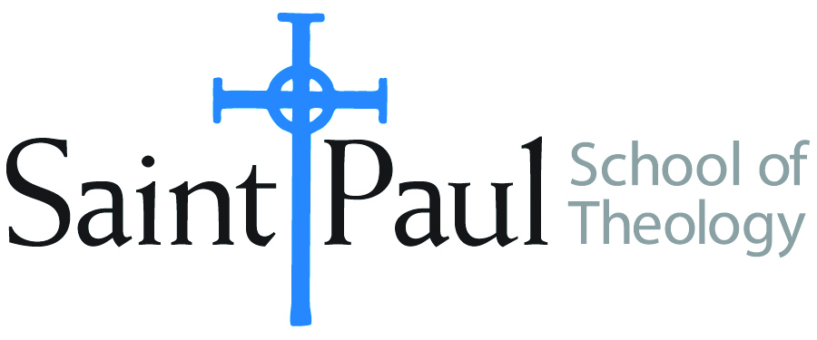
COURSE TEXTBOOK LIST INFORMATION

FACULTY INSTRUCTIONS |  |  | STUDENT INSTRUCTIONS  (Both Campuses)
For each semester taught, faculty should complete and submit a new form each time the course is taught and returned. Forms are due by the first day of registration for a given term.  DESKCOPY – ordered by faculty and adjuncts at a $200 max for 1st time use of text per course. Please fill out an Expense Reimbursement Form, attach all actual/delivered receipts, return via email or mail, and this should be reimbursed with your first stipend payment (or next payroll payment) |  |  | Students may acquire textbooks by ordering online via Amazon or other book retailer and having books shipped to them. Regardless of shopping / ordering method, students may check Cokesbury online for discount on text and certain texts may be sent free delivery.
COURSE INSTRUCTOR(S) | Nancy R. Howell
COURSE NUMBER & SECTION | CHL 511 AKHV AND AOHV
COURSE NAME | Building Communities in Context
COURSE SEMESTER & YEAR | Fall 2020
DATE OF SUBMISSION | 3/4/20

REQUIRED TEXTBOOKS LIST  BOOK TITLE and EDITION  (include subtitle if applicable) |  | AUTHOR(S) | # of PAGES to be read | PUBLISHER and DATE | 13-Digit ISBN  (without dashes) | LIST PRICE  (est)
1 | Ecclesiogenesis: The Base Communities Reinvent the Church | Boff,  Leonardo | 115 | Orbis,  1986 | 9780883442142 | $18.00
2 | Loaves and Fishes: The Inspiring Story of the Catholic Worker Movement, reprint ed. | Day,  Dorothy | 221 | Orbis,  2003 | 9781570751561 | $14.00
3 | Mujerista Theology | Isasi-Diaz,  Ada Maria | 210 | Orbis,  1996 | 9781570750816 | $19.00
4 | Christian Hospitality and Muslim Immigration in an Age of Fear | Kaemingk,  Matthew | 352 | Eerdmans,  2018 | 9780802874580 | $17.00
5 | Where Do We Go from Here: Chaos or Community? | King,  Martin Luther, &  Vincent Harding | 256 | Abingdon,  2010 | 9780807000670 | $14.00
6 | We Shall Not Be Moved: Methodists Debate Race, Gender, and Homosexuality | Nickell,  Jane Ellen | 218 | Pickwick Publications,  2014 | 9781625644848 | $25.00
7 | Working Class Rage: A Field Guide to White Anger | Sample,  Tex | 184 | Abingdon,  2018 | 97815018686139 | $13.00
 | TOTAL Number of Pages to Be Read |  | 1556

RECOMMENDED TEXTBOOKS LIST  BOOK TITLE and EDITION  (include subtitle if applicable) |  |  | AUTHOR(S) | # of PAGES to be read | PUBLISHER and DATE | 13-Digit ISBN  (without dashes) | LIST PRICE  (est)
1

