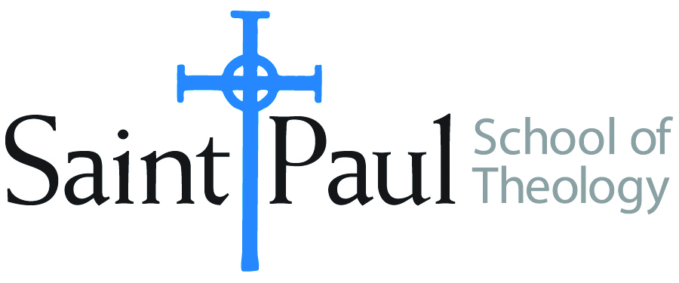
COURSE TEXTBOOK LIST INFORMATION

FACULTY INSTRUCTIONS |  |  | STUDENT INSTRUCTIONS  (Both Campuses)
For each semester taught, faculty should complete and submit a new form each time the course is taught and returned. Forms are due by the first day of registration for a given term.  DESKCOPY – ordered by faculty and adjuncts at a $200 max for 1st time use of text per course. Please fill out an Expense Reimbursement Form, attach all actual/delivered receipts, return via email or mail, and this should be reimbursed with your first stipend payment (or next payroll payment) |  |  | Students may acquire textbooks by ordering online via Amazon or other book retailer and having books shipped to them. Regardless of shopping / ordering method, students may check Cokesbury online for discount on text and certain texts may be sent free delivery.
COURSE INSTRUCTOR(S) | Casey Sigmon
COURSE NUMBER & SECTION | WOR 410 AKV AOV HYBRID
COURSE NAME | Introduction to Worship
COURSE SEMESTER & YEAR | Summer 2020
DATE OF SUBMISSION | Feb. 26, 2020

REQUIRED TEXTBOOKS LIST  BOOK TITLE and EDITION  (include subtitle if applicable) |  | AUTHOR(S) | # of PAGES to be read | PUBLISHER and DATE | 13-Digit ISBN  (without dashes) | LIST PRICE  (est)
1 | African American Christian Worship: Updated Edition | Melva Wilson Costen | 156 | Abingdon Press; Revised edition (September 1, 2007) | 978-0687646227 | 18.99
2 | Worship for the Whole People of God | Ruth C. Duck | 271 | Westminster John Knox, 2013 | 9780664234270 | 35
3 | Worship Come to Its Senses | Don E. Saliers | 96 | Abingdon Press, 1996 | 978-0687014583 | 17.99
4 | Let the Whole Church Say Amen!: A Guide for Those Who Pray in Public | Lawrence Hull Stookey | 165 | Abingdon, 2001 | 9780687090778 | 19.99
5 | Think Like a Filmmaker: Sensory-Rich Worship Design for Unforgettable Messages | Marcia McFee | 263 | Trokay Press, 2016 | 978-0997497809 | 29.99
6
7
 | TOTAL Number of Pages to Be Read

RECOMMENDED TEXTBOOKS LIST  BOOK TITLE and EDITION  (include subtitle if applicable) |  |  | AUTHOR(S) | # of PAGES to be read | PUBLISHER and DATE | 13-Digit ISBN  (without dashes) | LIST PRICE  (est)
1 |  | Accompany Them With Singing: The Christian Funeral | Thomas G. Long | 242 | Westminster John Knox, 2009 | 9780664239701 | 20
2 |  | This Holy Mystery: A United Methodist Understanding of Holy Communion | Gayle Carlton Felton | 79 | Discipleship Resources, 2005 | 978-0881774573 | 14
3 |  | By Water and the Spirit: Making Connections for Identity and Ministry (The Christian Initiation Series) | Gayle Carlton Felton | 64 | Discipleship Resources, 2003 | 978-0881772012 | 10
4

