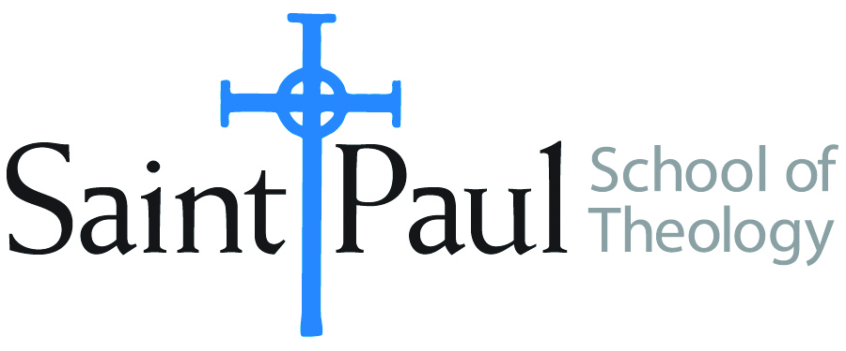
COURSE TEXTBOOK LIST INFORMATION

FACULTY INSTRUCTIONS |  |  | STUDENT INSTRUCTIONS (Both Campuses)
For each semester taught, faculty should complete and submit a new form each time the course is taught and returned. Forms are due by the first day of registration for a given term.  DESKCOPY – ordered by faculty and adjuncts at a $200 max for 1st time use of text per course. Please fill out an Expense Reimbursement Form, attach all actual/delivered receipts, return via email or mail, and this should be reimbursed with your first stipend payment (or next payroll payment) |  |  | Students may acquire textbooks by ordering online via Amazon or other book retailer and having books shipped to them. Regardless of shopping / ordering method, students may check Cokesbury online for discount on text and certain texts may be sent free delivery.
COURSE INSTRUCTOR(S) | Kristen E. Kvam
COURSE NUMBER & SECTION | THL 443 AKV
COURSE NAME | Theological Commentary, Feminism, and the Psalms
COURSE SEMESTER &YEAR | Fall Semester, 2020
DATE OF SUBMISSION | March 9, 2020

REQUIRED TEXTBOOKS LIST
BOOK TITLE and EDITION  (include subtitle if applicable) |  | AUTHOR(S) | No. of  PAGES to be read | PUBLISHER and DATE | 13-Digit ISBN  (without dashes) | LIST PRICE  (estimate) | DESK COPY
1 | The Book of Psalms: A Translation with Commentary. | Alter, Robert | About 100 | WW Norton. 2007. | 9780393337044
2 | Psalms in Interpreting Biblical Texts series. | Brown, William P. | 180 | Abingdon, 2010. | 9780687008452
3 | The Inclusive Psalms. | Priests for Equality | About 100 | Priests for Equality, 1997. | 9780964427921
4 | Journey Through the Psalms, Revised and Expanded | Hopkins, Denise Dombkowski | 176 | Chalice, 2002 | 9780827217140
5 | Psalms in Chalice Commentaries for Today series. | Steussy, Marti J. | 210 | Chalice, 2004 | 9780827205260
6 | Bible—any translation; variety valued.
 | TOTAL Number of Pages to Be Read |  | 816

RECOMMENDED TEXTBOOKS LIST
BOOK TITLE and EDITION  (include subtitle if applicable) |  | AUTHOR(S) | No. of  PAGES to be read | PUBLISHER and DATE | 13-Digit ISBN  (without dashes) | LIST PRICE  (estimate) | DESK COPY
1 | The Women’s Bible Commentary, Revised and Updated, Third Edition. | Newsom, Carol A., Sharon Ringe, and Jacqueline Lapsley, ed. | 40-50 | Westminster John Knox, 2012 | 9780664237073 |  | 1
2 | Feminist Biblical Interpretation: A Compendium of Critical Commentary . . . | Schottroff, Luise, and Marie-Theres Wacker | 25 | Wm. B. Eerdmans, 2012 | 9780802860972 |  | 1
3 | Wisdom and Psalms: A Feminist Companion to the Bible (Second Series) | Brenner, Athalya, and Carole Fontaine | 50- 60 | Sheffield Academic Press, 1998. |  |  | 1
4 | The Inclusive Bible: The First Eqalitarian Translation |  |  | Rowman and Littlefield,  2007 | 9781580512138  or ebbook;  9781580512268 |  | 1
*****Please see the note from kris kvam on the second page*****

Special Instructions to class participants:

Notes from Kris Kvam

1. The “Recommended books” are ones from which there will be a few short reading assignments. I am recommending them for purchase (or to put on a Gift list) as Ideas for building students’ professional libraries.

2. The last item in the Recommended list is an inclusive translation of the entire biblical canon. if someone purchases this, there would be no need to also purchase the inclusive psalms translation that is listed under required books.

3. Other Recommended Books will be described during Class Sessions.

4. Many course Readings will be articles and essays so are not on this book order.

