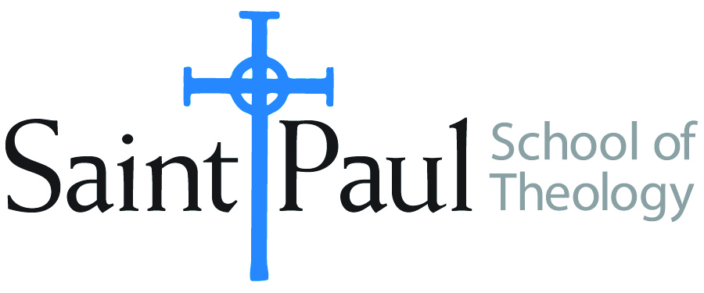
COURSE TEXTBOOK LIST INFORMATION

FACULTY INSTRUCTIONS |  |  | STUDENT INSTRUCTIONS  (Both Campuses)
For each semester taught, faculty should complete and submit a new form each time the course is taught and returned. Forms are due by the first day of registration for a given term.  DESKCOPY – ordered by faculty and adjuncts at a $200 max for 1st time use of text per course. Please fill out an Expense Reimbursement Form, attach all actual/delivered receipts, return via email or mail, and this should be reimbursed with your first stipend payment (or next payroll payment) |  |  | Students may acquire textbooks by ordering online via Amazon or other book retailer and having books shipped to them. Regardless of shopping / ordering method, students may check Cokesbury online for discount on text and certain texts may be sent free delivery.
COURSE INSTRUCTOR(S) | Casey Sigmon
COURSE NUMBER & SECTION | PCM 316
COURSE NAME | Preaching and Technology
COURSE SEMESTER & YEAR | Fall 2020
DATE OF SUBMISSION | March 26, 2020

REQUIRED TEXTBOOKS LIST  BOOK TITLE and EDITION  (include subtitle if applicable) |  | AUTHOR(S) | # of PAGES to be read | PUBLISHER and DATE | 13-Digit ISBN  (without dashes) | LIST PRICE  (est)
1 | The Digital Cathedral: Networked Ministry in a Wireless World. | Keith Anderson and Elizabeth Drescher | 256 | Morehouse Pub. 2015 | 978-0819229953 | 28.00
2
3
 | TOTAL Number of Pages to Be Read |  | 256

RECOMMENDED TEXTBOOKS LIST  BOOK TITLE and EDITION  (include subtitle if applicable) |  |  | AUTHOR(S) | # of PAGES to be read | PUBLISHER and DATE | 13-Digit ISBN  (without dashes) | LIST PRICE  (est)
1 |  | Networked Theology: Negotiating Faith in Digital Culture | Heidi A. Campbell and Stephen Garner | 186 | BakerBooks, 2016 | 978-0801049149 | 24.00
2 |  | Thy Kingdom Connected: What the Church Can Learn from Facebook, the Internet, and Other Networks | Dwight Friesen | 192 | BakerBooks, 2009 | 978-0801071638 | 14.99
3 |  | he Social Media Gospel: Sharing the Good News in New Ways, Second Edition | Meredith Gould | 200 | The Liturgical Press, 2015 | 978-0814647073 | 16.99
4 |  | Orality and Literacy 30th Anniversary Edition | Walter J. Ong | 264 | Routledge, 2002 | 978-0415538381 | 41.95

