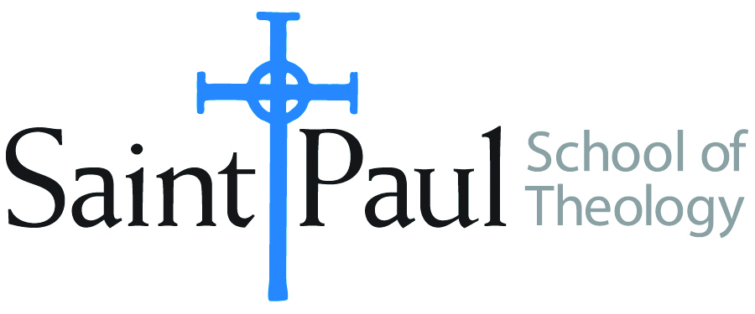
COURSE TEXTBOOK LIST INFORMATION
FACULTY INSTRUCTIONS |  |  | STUDENT INSTRUCTIONS  (Both Campuses)
For each semester taught, faculty should complete and submit a new form each time the course is taught and returned. Forms are due by the first day of registration for a given term.  DESKCOPY – ordered by faculty and adjuncts at a $200 max for 1st time use of text per course. Please fill out an Expense Reimbursement Form, attach all actual/delivered receipts, return via email or mail, and this should be reimbursed with your first stipend payment (or next payroll payment) |  |  | Students may acquire textbooks by ordering online via Amazon or other book retailer and having books shipped to them. Regardless of shopping / ordering method, students may check Cokesbury online for discount on text and certain texts may be sent free delivery.
COURSE INSTRUCTOR(S) | Melissa Tubbs Loya
COURSE NUMBER & SECTION | HBS 428 AKHV
COURSE NAME | Women in the Hebrew Bible
COURSE SEMESTER & YEAR | Summer 2020
DATE OF SUBMISSION | 3/10/20

REQUIRED TEXTBOOKS LIST  BOOK TITLE and EDITION  (include subtitle if applicable) |  | AUTHOR(S) | # of PAGES to be read | PUBLISHER and DATE | 13-Digit ISBN  (without dashes) | LIST PRICE  (est)
1 | Reading the Women of the Bible: A New Interpretation of Their Stories, Reprint ed. | Tikva Frymer-Kinsky | 480 | Schocken, 2004 | 9780805211825 | $15 on Amazon
2 | Rediscovering Eve: Ancient Israelite Women in Context | Carol Meyers | 312 | Oxford University Press, 2012 | 9780199734627 | $32 on Amazon
3 | Women’s Bible Commentary, 3rd ed., Rev. and updated | Carol A. Newsom, Sharon H. Ringe, Jacqueline E. Lapsly | approx. 250 | Westminster John Knox, 2012 | 9780664237073 | $33 on Amazon
4 | EITHER The HarperCollins Study Bible: Fully Revised & Updated (NRSV)* | Attridge, H., ed. | selections | HarperOne, 2006 | 9780061228407 | b/w $25 45 on Amazon
5 | OR The New Oxford Annotated Bible with the Apocrypha, New Revised Standard Version, 5th College Ed.* | Coogan, M. D., ed. | selections | Oxford University Press, 2018 | 9780190276072 | b/w $25–45 on Amazon
6 | *students will need one NRSV study Bible
 | TOTAL Number of Pages to Be Read |  | 1042** | **plus required biblical passages and optional supplemental readings; links to be put on Moodle

RECOMMENDED TEXTBOOKS LIST  BOOK TITLE and EDITION  (include subtitle if applicable) |  | AUTHOR(S) | # of PAGES to be read | PUBLISHER and DATE | 13-Digit ISBN  (without dashes) | LIST PRICE  (est)
1 | Women in Scripture: A Dictionary of Named and Unnamed Women in the Hebrew Bible, the Apocryphal/Deuterocanonical Books, and the New Testament | Carol Meyers, Toni Craven, Ross Shepard Kraemer, eds. | selections | Wm. B. Eerdmans Publishing Company, 2001 | 9780802849625 | $33 on Amazon

