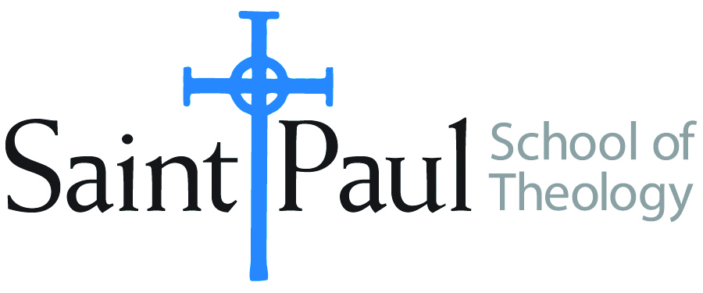
COURSE TEXTB
COURSE TEXTBOOK LIST INFORMATION

FACULTY INSTRUCTIONS |  |  | STUDENT INSTRUCTIONS  (Both Campuses)
For each semester taught, faculty should complete and submit a new form each time the course is taught and returned. Forms are due by the first day of registration for a given term.  DESKCOPY – ordered by faculty and adjuncts at a $200 max for 1st time use of text per course. Please fill out an Expense Reimbursement Form, attach all actual/delivered receipts, return via email or mail, and this should be reimbursed with your first stipend payment (or next payroll payment) |  |  | Students may acquire textbooks by ordering online via Amazon or other book retailer and having books shipped to them. Regardless of shopping / ordering method, students may check Cokesbury online for discount on text and certain texts may be sent free delivery.
COURSE INSTRUCTOR(S) Elaine Robinson
COURSE NUMBER & SECTION | THL 512 and THL 412 (AKE/AOE)
COURSE NAME | Theology and Church's Ministry: Liberating the Church
COURSE SEMESTER & YEAR | Summer 2020
DATE OF SUBMISSION | 2/22/2020

REQUIRED TEXTBOOKS LIST
BOOK TITLE and EDITION  (include subtitle if applicable) |  | AUTHOR(S) | No. of  PAGES to be read | PUBLISHER and DATE | 13-Digit ISBN  (without dashes) | LIST PRICE  (estimate) | DESK COPY
1 | Being Church: An Ecclesiology for the Rest of Us | Andinach, Pablo | 104 | Wipf and Stock (2014) | 9781620321355 | $17
2 | Models of the Church, expanded edition | Dulles,  Avery | 300 | Image Classics (1991) | 9780385133685 | $12
3 | Dear Church: A Love Letter from a Black Preacher to the Whitest Denomination in the US | Duncan,  Lenny | 130 | Fortress Press (2019) | 9781506452562 | $13
4
5
6
7
 | TOTAL Number of Pages to Be Read |  | 534

RECOMMENDED TEXTBOOKS LIST
BOOK TITLE and EDITION  (include subtitle if applicable) |  | AUTHOR(S) | No. of  PAGES to be read | PUBLISHER and DATE | 13-Digit ISBN  (without dashes) | LIST PRICE  (estimate) | DESK COPY
1
2
3
4

Special Instructions to Cokesbury:

