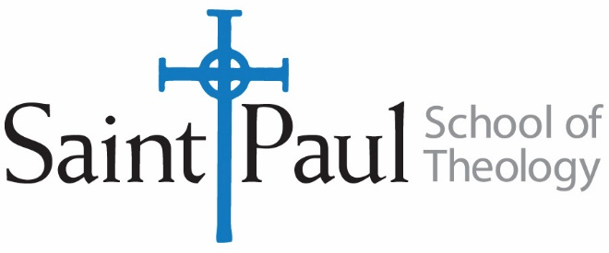

Attachment: Photo

FOR IMMEDIATE RELEASE: May XX, 20XX

[Name] Graduates from Saint Paul School of Theology
[Leawood, KS or Oklahoma City, OK] – [Name] of [City, State] graduated with [degree or certificate] with a specialization in [specialization] from Saint Paul School of Theology on May XX, 20XX. [Last name] is a member of the [Denomination or UM Conference].
Following graduation, [Last name] plans to [future plans such as where you’ll be working or continuing education].
Saint Paul School of Theology is a seminary of the United Methodist Church with one mission in two locations. The Oklahoma campus thrives in a collaboration with Oklahoma City University in Oklahoma City, and in partnership with the United Methodist Church of the Resurrection, the Kansas Campus serves the Greater Kansas City Metro Area. Graduates leave with tools and first-hand experience necessary to meet the needs of a changing world. The seminary offers a Certificate in Theological Formation, Master of Arts (Theological Studies), Master of Arts in Christian Ministry, Master of Divinity and Doctor of Ministry. Learn more at www.spst.edu.

###

