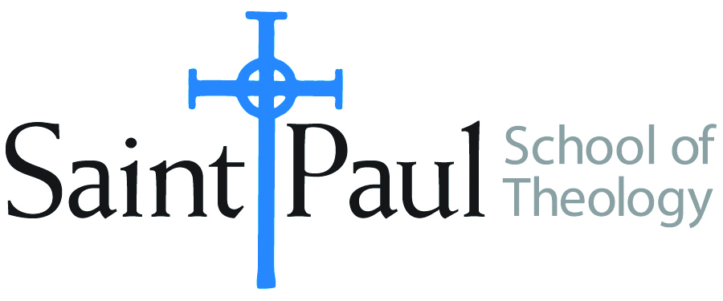
COURSE TEXTBOOK LIST INFORMATION

FACULTY INSTRUCTIONS |  |  | STUDENT INSTRUCTIONS  (Both Campuses)
For each semester taught, faculty should complete and submit a new form for every course and return to Melissa Whalen in the Academic Life office. Forms are due by the first day of registration for a given term. Desk copies for Teaching Assistants must be requested on this form. It is up to the publishers’ discretion whether or not to provide desk copies for teaching assistants. |  |  | Students may acquire textbooks by ordering online or directly from the publisher, which in some cases, the prices are more economical. Regardless of shopping/ordering method, students may check Cokesbury online for discount on text, or follow recommendations by your professor.
COURSE INSTRUCTOR(S) | Casey Sigmon
COURSE NUMBER & SECTION | WOR 410 AKV AOV HYBRID
COURSE NAME | Introduction to Worship
COURSE SEMESTER &YEAR | Summer 2019
DATE OF SUBMISSION | March 11, 2019

REQUIRED TEXTBOOKS LIST
BOOK TITLE and EDITION  (include subtitle if applicable) |  | AUTHOR(S) | No. of  PAGES to be read | PUBLISHER and DATE | 13-Digit ISBN  (without dashes) | LIST PRICE  (estimate) | DESK COPY
1 | Worship for the Whole People of God | Ruth C. Duck | 271 | Westminster John Knox, 2013 | 9780664234270 | 35
2 | Worship as Theology: Foretaste of Glory Divine | Don E. Saliers | 230 | Abingdon, 1994 | 9780687146932 | 18.99
3 | Let the Whole Church Say Amen!:A Guide for Those Who Pray in Public | Lawrence Hull Stookey | 165 | Abingdon, 2001 | 9780687090778 | 19.99
4 | Accompany Them With Singing: The Christian Funeral | Thomas G. Long | 242 | Westminster John Knox, 2009 | 9780664239701 | 20
5
6
7
 | TOTAL Number of Pages to Be Read

RECOMMENDED TEXTBOOKS LIST
BOOK TITLE and EDITION  (include subtitle if applicable) |  | AUTHOR(S) | No. of  PAGES to be read | PUBLISHER and DATE | 13-Digit ISBN  (without dashes) | LIST PRICE  (estimate) | DESK COPY
1
2
3
4

Special Instructions to Cokesbury:

