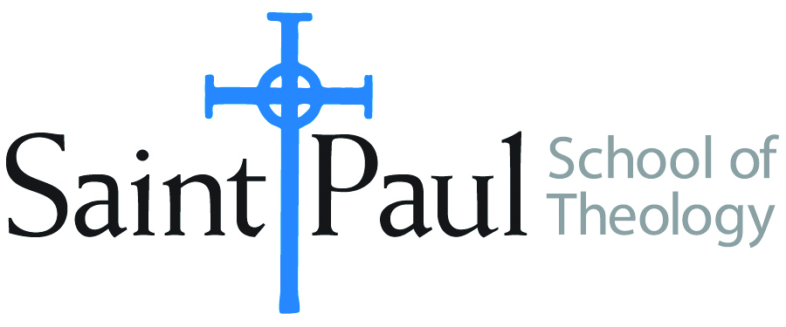
COURSE TEXTBOOK LIST INFORMATION

FACULTY INSTRUCTIONS |  |  | STUDENT INSTRUCTIONS  (Both Campuses)
For each semester taught, faculty should complete and submit a new form for every course and return to Melissa Whalen in the Academic Life office. Forms are due by the first day of registration for a given term. Desk copies for Teaching Assistants must be requested on this form. It is up to the publishers’ discretion whether or not to provide desk copies for teaching assistants. |  |  | Students may acquire textbooks by ordering online or directly from the publisher, which in some cases, the prices are more economical. Regardless of shopping/ordering method, students may check Cokesbury online for discount on text, or follow recommendations by your professor.
COURSE INSTRUCTOR(S) | Elaine Robinson
COURSE NUMBER & SECTION | MIN 301 AKHV, AOHV
COURSE NAME | Introduction to Ministry
COURSE SEMESTER &YEAR | Fall 2018
DATE OF SUBMISSION | 2-23-2018

REQUIRED TEXTBOOKS LIST
BOOK TITLE and EDITION  (include subtitle if applicable) |  | AUTHOR(S) | No. of  PAGES to be read | PUBLISHER and DATE | 13-Digit ISBN  (without dashes) | LIST PRICE  (estimate) | DESK COPY
1 | Covenants and Care | Gary Harbaugh, et al |  | Fortress Press, 1998 | 9780800629885 | $12
2 | Soul Feast, newly revised edition | Marjorie Thompson |  | Westminster John Knox, 2014 | 9780664239244 | $13.50
3 | Pastor: The Theology and Practice of Ordained Ministry, revised edition | William Willimon |  | Abingdon Press, 2016 | 9781501804908 | $20
4 | Let Your Life Speak | Parker Palmer |  | Jossey Bass, 1999 | 9780787947354 | $10
5 | How to Think Theologically, 3rd edition | Howard Stone & James Duke |  | Fortress Press, 2013 | 9780800699321 | $14
6
7
 | TOTAL Number of Pages to Be Read |  | Many

RECOMMENDED TEXTBOOKS LIST
BOOK TITLE and EDITION  (include subtitle if applicable) |  | AUTHOR(S) | No. of  PAGES to be read | PUBLISHER and DATE | 13-Digit ISBN  (without dashes) | LIST PRICE  (estimate) | DESK COPY
1
2
3
4

Special Instructions to Cokesbury:

