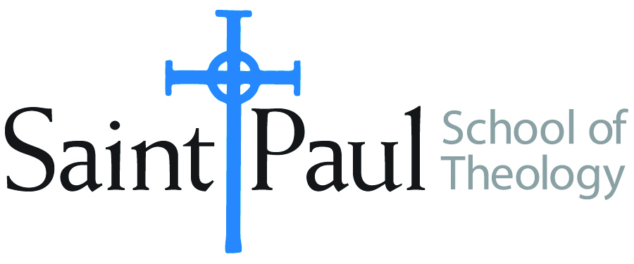
COURSE TEXTBOOK LIST INFORMATION

FACULTY INSTRUCTIONS |  |  | STUDENT INSTRUCTIONS  (Both Campuses)
For each semester taught, faculty should complete and submit a new form for every course and returned, even if no desk copies are needed, just type “none”. Forms are due by the first day of registration for a given term. Desk copies for Teaching Assistants must be requested on this form, if needed. |  |  | Students may acquire textbooks by ordering online via Amazon or other book retailer and having books shipped to them. Regardless of shopping/ordering method, students may check Cokesbury online for discount on text and certain text may be sent free delivery.
COURSE INSTRUCTOR(S) | David M. Wilson
COURSE NUMBER & SECTION | PCM 361 AKV AOV-focus-Native American Ministries
COURSE NAME | Native American Ministries
COURSE SEMESTER & YEAR | SPRING 2019
DATE OF SUBMISSION | December 20, 2018

REQUIRED TEXTBOOKS LIST
BOOK TITLE and EDITION  (include subtitle if applicable) |  | AUTHOR(S) | # of PAGES to be read | PUBLISHER and DATE | 13-Digit ISBN  (without dashes) | LIST PRICE  (est) | DESK COPY
1 | On This Spirit Walk | Henrietta Mann and Anita Phillips | 119 | Native American Comprehensive Plan, 2012 | 978-1-4267-5841-6 | 15.00 | none
2
3
4
5
6
7
 | TOTAL Number of Pages to Be Read |  | 119

RECOMMENDED TEXTBOOKS LIST
BOOK TITLE and EDITION  (include subtitle if applicable) |  | AUTHOR(S) | # of PAGES to be read | PUBLISHER and DATE | 13-Digit ISBN  (without dashes) | LIST PRICE  (est) | DESK COPY
1
2
3
4

Special Instructions to Cokesbury:

