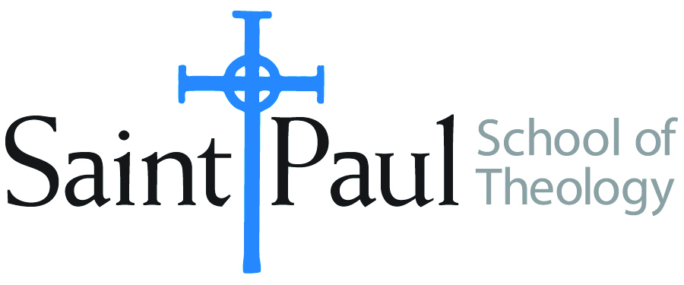
COURSE TEXTBOOK LIST INFORMATION

FACULTY INSTRUCTIONS |  |  | STUDENT INSTRUCTIONS  (Both Campuses)
For each semester taught, faculty should complete and submit a new form for every course and return to Ethel Tomlinson, Registrar Clerk/Administrative Support. Forms are due by the first day of registration for a given term. Desk copies for Teaching Assistants must be requested on this form. It is up to the publishers’ discretion whether or not to provide desk copies for teaching assistants. |  |  | Students may acquire textbooks by ordering online or directly from the publisher, which in some cases, the prices are more economical. Regardless of shopping/ordering method, students may check Cokesbury online for discount on text, or follow recommendations by your professor.
COURSE INSTRUCTOR(S) | Dr. Kristen E. Kvam
COURSE NUMBER & SECTION | THL 301
COURSE NAME | INTRODUCTION TO SYSTEMATIC THEOLOGY
COURSE SEMESTER &YEAR | Spring, 2019
DATE OF SUBMISSION | October 26, 2018

REQUIRED TEXTBOOKS LIST
BOOK TITLE and EDITION  (include subtitle if applicable) |  | AUTHOR(S) | No. of  PAGES to be read | PUBLISHER and DATE | 13-Digit ISBN  (without dashes) | LIST PRICE  (estimate) | DESK COPY
1 | The Humanity of God | Barth, Karl | 90 | Westminster John Knox, 1960 | 9780804206129 | 2.50 | no
2 | Constructive Theology: A Contemporary Approach to Classical Themes | Jones, Serene and Paul Lakeland, ed. | 160 | Fortress Press, 2005 | 9780800636838 | 15.00 | no
3 | Theological Worlds: Understanding the Alternative Rhythms of Christian Belief | Jones, W. Paul | 250 | Abingdon, 1989 | 9780687414703 | 2.00 | no
4 | Why Study Theology? | Luck, Donald | 150 | Chalice, 1999 | 9780226803418 | 1.00 | no
5 | Belonging to God: A Commentary on a Brief Statement of Faith | Placher, William, and David Willis-Watkins | 200 | Westminster John Knox, 1992 | 8780664252960 | 1.00 | no
6 | Awake to the Moment: An Introduction to Theology | Schneider, Laurel, and Stephen G. Ray, Jr., ed. | 250 | Westminster John Knox, | 9780664261887 | 16.00 | yes
7 | Biblical Religion and the Search for Ultimate Reality | Tillich, Paul | 90 | University of Chicago Press, 1964 | 9780226803418 | 3.00 | no
 | TOTAL Number of Pages to Be Read |  | 1190

RECOMMENDED TEXTBOOKS LIST
BOOK TITLE and EDITION  (include subtitle if applicable) |  | AUTHOR(S) | No. of  PAGES to be read | PUBLISHER and DATE | 13-Digit ISBN  (without dashes) | LIST PRICE  (estimate) | DESK COPY
1 | Christian Thought Revisited: Three Types of Theology | Gonzalez, Justo |  | Orbis, 1999 | 978170752551 | 9.97 | no
2 | Christian Doctrine, Revised Ed. | Guthrie, Shirley |  | Westminster John Knox, 1994 | 9780664253684 | 0.49 | no
3 | Readings in Christian Theology | Hodgson, Peter, and Robert King, ed. |  | Fortress, 1985 | 9780800618490 | 2.34 | no
4 | Quest for the Living God | Johnson, Elizabeth |  | Bloomsbury Academic, 2007 | 9780826417701 | 3.55 | no
5 | Worlds Within a Congregation: Dealing with Theological Diversity | Jones, W. Paul |  | Abingdon Press, 2000 | 9780687084340 | 11.59 | no
6 | New and Enlarged Handbook of Christian Theological | Musser, Donald, and Joseph Price |  | Abingdon, 2003 | 9780687091126 | 21.00 | no
7 | Dictionary of Feminist Theologies | Russell, Letty, and Clarkson, J. Shannon |  | Westminster John Knox, 1996 | 9780664220587 | 3.94 | no

SPECIAL INSTRUCTIONS:

Kris Kvam recommends that you purchase Books that she has put on this recommended list after she speaks about them in class.

