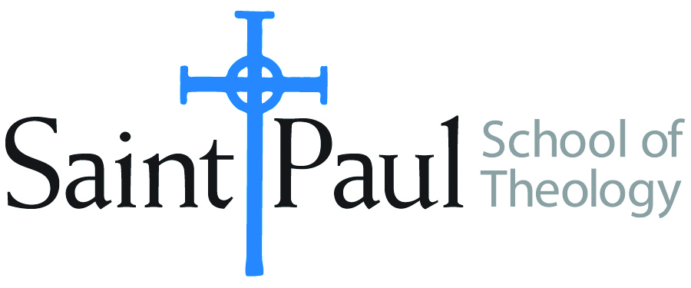
COURSE TEXTBOOK LIST INFORMATION

FACULTY INSTRUCTIONS |  |  | STUDENT INSTRUCTIONS  (Both Campuses)
For each semester taught, faculty should complete and submit a new form for every course and returned, even if no desk copies are needed, just type “none”. Forms are due by the first day of registration for a given term. Desk copies for Teaching Assistants must be requested on this form, if needed. |  |  | Students may acquire textbooks by ordering online via Amazon or other book retailer and having books shipped to them. Regardless of shopping/ordering method, students may check Cokesbury online for discount on text and certain text may be sent free delivery.
COURSE INSTRUCTOR(S) | Knight
COURSE NUMBER & SECTION | SFR 504 AKE AOE
COURSE NAME | Spiritual Formation Seminar IV
COURSE SEMESTER & YEAR | SPRING 2019
DATE OF SUBMISSION

REQUIRED TEXTBOOKS LIST
BOOK TITLE and EDITION  (include subtitle if applicable) | AUTHOR(S) | # of PAGES to be read | PUBLISHER and DATE | 13-Digit ISBN  (without dashes) | LIST PRICE  (est) | DESK COPY

The books are assigned by the Academy for Spiritual Formation, and the students should be able to attain them from there.

