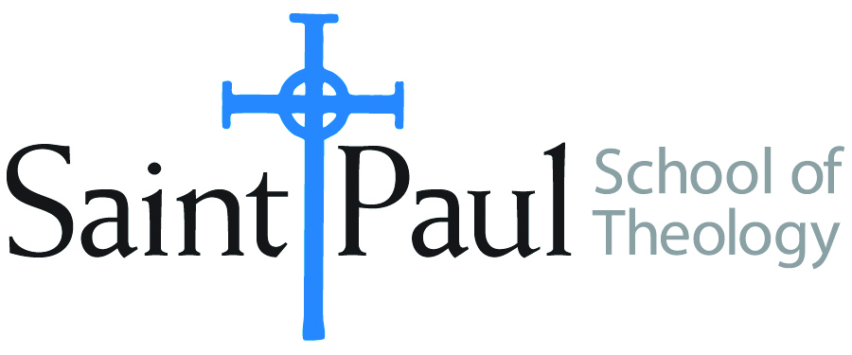
COURSE TEXTBOOK LIST INFORMATION

FACULTY INSTRUCTIONS |  |  | STUDENT INSTRUCTIONS (Both Campuses)
For each semester taught, faculty should complete and submit a new form for every course and return to Megan Temchin in the Academic Life office. Forms are due by the first day of registration for a given term. Desk copies for Teaching Assistants must be requested on this form. It is up to the publishers’ discretion whether or not to provide desk copies for teaching assistants. |  |  | Students may acquire textbooks by ordering online at the Cokesbury Virtual Bookstore and having books shipped to them. Regardless of shopping/ordering method, students may be eligible for a clergy discount by ordering through Cokesbury!  Abingdon Press textbook titles are 35% off in the store.  Textbook lists will be available online at http://www.spst.edu/registrar/coursematerial
COURSE INSTRUCTOR(S) | Amy Oden
COURSE NUMBER & SECTION | HST 424
COURSE NAME | Hospitality in Christian History and Practice
COURSE SEMESTER &YEAR | Spring 2019 |  |  | Q
DATE OF SUBMISSION | November 2018

REQUIRED TEXTBOOKS LIST
BOOK TITLE and EDITION  (include subtitle if applicable) |  | AUTHOR(S) | No. of  PAGES to be read | PUBLISHER and DATE | 13-Digit ISBN  (without dashes) | LIST PRICE  (estimate) | DESK COPY
1 | God’s Welcome: Hospitality for a Gospel-Hungry World | Amy Oden | 128 | Pilgrim Press, 2008 | 978-0829817355 | $14.00 | no
2 | Making Room: Recovering Hospitality as a Christian Tradition | Christine Pohl | 200 | Eerdmans, 1999 | 978-0802844316 | $16.00 | 1
4 |  |  |  |  |  |  | 1
4
5
6
7
 | TOTAL Number of Pages to Be Read

RECOMMENDED TEXTBOOKS LIST
BOOK TITLE and EDITION  (include subtitle if applicable) |  | AUTHOR(S) | No. of  PAGES to be read | PUBLISHER and DATE | 13-Digit ISBN  (without dashes) | LIST PRICE  (estimate) | DESK COPY
1 | Reaching Out: The Three Movements of the Spiritual Life | Henri Nouwen | 40 | Doubleday, 1975 | 978-0385236829 | $11.00 | 1
 | Hospitality and the Other: Pentecost, Christian Practices and the Neighbor | Amos Yong | 80 | Orbis, 2008 | 978-1570757723 | $22.00
4 | Dear Sisters: A Womanist Practice of Hospitality | N. Lynne Westfield | 30 | Pilgrim Press, 2007 | 978-0829814491 | $23.00

Special Instructions to Cokesbury:

