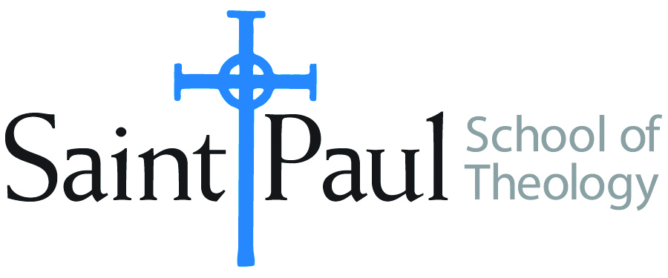
COURSE TEXTBOOK LIST INFORMATION

FACULTY INSTRUCTIONS |  |  | STUDENT INSTRUCTIONS  (Both Campuses)
For each semester taught, faculty should complete and submit a new form for every course and returned, even if no desk copies are needed, just type “none”. Forms are due by the first day of registration for a given term. Desk copies for Teaching Assistants must be requested on this form, if needed. |  |  | Students may acquire textbooks by ordering online via Amazon or other book retailer and having books shipped to them. Regardless of shopping/ordering method, students may check Cokesbury online for discount on text and certain text may be sent free delivery.
COURSE INSTRUCTOR(S) | various
COURSE NUMBER & SECTION | CTX 302 AK ; CTX 302 BK ; CTX 431 AK ; CTX 431 AO ; CTX 431 AKE ;
COURSE NAME | CTX – various Contextual Ed
COURSE SEMESTER & YEAR | SPRING 2019
DATE OF SUBMISSION

REQUIRED TEXTBOOKS LIST
BOOK TITLE and EDITION  (include subtitle if applicable) | AUTHOR(S) | # of PAGES to be read | PUBLISHER and DATE | 13-Digit ISBN  (without dashes) | LIST PRICE  (est) | DESK COPY

The ctx classes require no books

