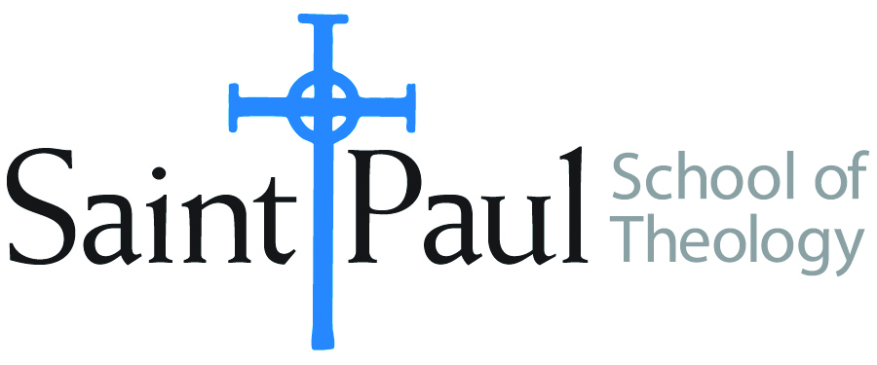
COURSE TEXTBOOK LIST INFORMATION

FACULTY INSTRUCTIONS |  |  | STUDENT INSTRUCTIONS  (Both Campuses)
For each semester taught, faculty should complete and submit a new form for every course and return to Ethel Tomlinson in the Registrar’s Office. Forms are due by the first day of registration for a given term. Faculty should request Desk copies for Teaching Assistants on this form. It is up to the publishers’ discretion whether or not to provide desk copies for teaching assistants. |  |  | Students may acquire textbooks by ordering online or directly from the publisher, which in some cases, the prices are more economical. Regardless of shopping/ordering method, students may check Cokesbury online for discount on text, or follow recommendations by your professor.
COURSE INSTRUCTOR(S) | Anne Walker
COURSE NUMBER & SECTION | CRE 382
COURSE NAME | Youth Ministry AKE AOE
COURSE SEMESTER &YEAR | Spring 2019
DATE OF SUBMISSION | 11/9/18

REQUIRED TEXTBOOKS LIST
BOOK TITLE and EDITION  (include subtitle if applicable) |  | AUTHOR(S) | No. of  PAGES to be read | PUBLISHER and DATE | 13-Digit ISBN  (without dashes) | LIST PRICE  (estimate) | DESK COPY
1 | OMG: A Youth Ministry Handbook | Dean | 163 | Abingdon, 2010 | 9781426700088 | 5.98
2 | Nurturing Different Dreams | Turpin & Walker | 152 | Pickwick, 2014 | 1625640099 | 18.00
3 | Exploding Stars, Dead Dinosaurs, and Zombies | Root | 312 | Fortress, 2018 | 9781506446745 | 19.99 | yes
4 | Beyond the Screen | Zirschky | 150 | Abingdon, 2015 | 9781501810077 | 15.38 | yes
5 | Smaller Church Youth Ministry | Fuscus | 160 | Abingdon, 2016 | 9781501825811 | 14.28 | Yes
6 | The Barefoot Way | Baker | 144 | Westminster John Knox, 2014 | 978-0664238025 | 13.78
7
 | TOTAL Number of Pages to Be Read

RECOMMENDED TEXTBOOKS LIST
BOOK TITLE and EDITION  (include subtitle if applicable) |  | AUTHOR(S) | No. of  PAGES to be read | PUBLISHER and DATE | 13-Digit ISBN  (without dashes) | LIST PRICE  (estimate) | DESK COPY
1 | Raising Hope | Wimberly | 24.99 | United Methodist GBHE, 2017 | 9780938162346 | 24.99
2 | Arm in Arm with Adolescent Girls | Peck-McClain | 21.00 | Pickwick, 2018 | 9781532634789 | 21.00
3 | Practicing Discernment with Youth | White | 209 | Pilgrim, 2005 | 9780829816310 | 2.15
4 | Finding God in the Graffiti | Rogers | 212 | Pilgrim, 2011 | 9780829818024 | 23.96
 | Deep Justice in a Broken World | Powell | 256 | Zondervan, 2007 | 9780310273776 | 18.69
 | Contemplative Youth Ministry | Yaconelli | 256 | Zondervan, 2006 | 9780310267775 | 13.96
 | Drama Tweens | Turpin | 118 | Wipf & Stock, 2017 | 9781532608001 | 17.00
 | Cut Dead But Still Alive | Ellison | 206 | Abingdon, 2013 | 9781426703041 | 22.14 | Yes

Special Instructions to Cokesbury:
Students will be asked to choose one book from the recommended list. In addition, they will be required to watch the following movies:

The Education of Shelby knox

Soul searching

