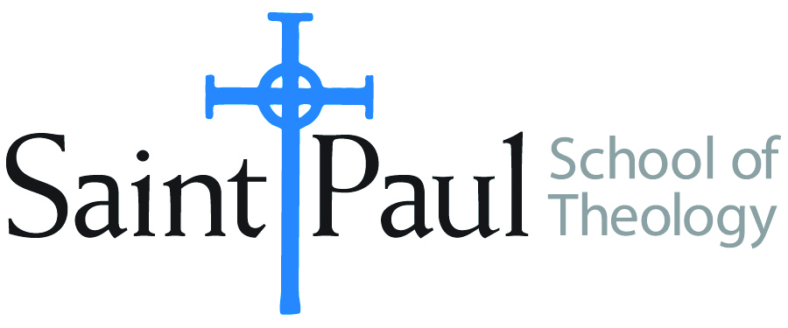
COURSE TEXTBOOK LIST INFORMATION

FACULTY INSTRUCTIONS |  |  | STUDENT INSTRUCTIONS (Both Campuses)
For each semester taught, faculty should complete and submit a new form for every course and return to Joshua Farrell in the Academic Life office. The due dates are September 1 for the following Spring and Summer, and February 1 for the following Fall and Winter. If books are needed in the bookstore at an earlier date than normal, please give exact date in the “Special Instructions” section. Due to limited space, Cokesbury may only have books on hand for the current and upcoming semesters. Desk copies for Teaching Assistants must be requested on this form. It is up to the publishers’ discretion whether or not to provide desk copies for teaching assistants. |  |  | Students may acquire textbooks by shopping at their campus Cokesbury store (in person, by email, or by fax), or by ordering online at the Cokesbury Virtual Bookstore and having books shipped to them. Regardless of shopping/ordering method, students may be eligible for a clergy discount by ordering through Cokesbury!  Abingdon Press textbook titles are 35% off in the store.  Textbook lists will be available online at http://www.spst.edu/registrar/coursematerial
COURSE INSTRUCTOR(S) | Lee Webb
COURSE NUMBER & SECTION | MIN 231 AOV
COURSE NAME | Information Literacy in Theological Education
COURSE SEMESTER &YEAR | FALL 2018
DATE OF SUBMISSION | 8/2/2018

REQUIRED TEXTBOOKS LIST
BOOK TITLE and EDITION  (include subtitle if applicable) |  | AUTHOR(S) | No. of  PAGES to be read | PUBLISHER and DATE | 13-Digit ISBN  (without dashes) | LIST PRICE  (estimate) | DESK COPIES
1 | Quality Research Papers: For Students of Religion and Theology, 3rd ed. | Nancy Jean Vyhmeister and Terry Dwain Robertson | 300 | Zondervan; 2014 | 9780310514022 | $19.99
3 |  |  |  |  |  | $
8 |  |  |  |  |  | $
 | TOTAL Number of Pages to Be Read |  | 300

RECOMMENDED TEXTBOOKS LIST
BOOK TITLE and EDITION  (include subtitle if applicable) |  | AUTHOR(S) | No. of  PAGES to be read | PUBLISHER and DATE | 13-Digit ISBN  (without dashes) | LIST PRICE  (estimate) | DESK COPIES
1 | Writing Theology Well: A Rhetoric for Theological and Biblical Writers, any ed. | Lucretia Yaghjian | 73 | Bloomsbury,  2006 or  2015 | 978-0826418852  978-0567499172* | $29.95
2 | From Topic to Thesis: A Guide to Theological Research | Michael Kibbe |  | IVP, 2016 | 978-0830851317 | $12.00
3
 | TOTAL Number of Pages to Be Read |  | 73

Special Instructions from Faculty to Cokesbury Bookstore:
For purposes of this course, either the first or second edition of this text would be acceptable, as the sections used are not significantly revised in the newer edition. Only the sections pertaining to research are used in this course, but the text is highly recommended for students who are planning to write a thesis or dissertation.

