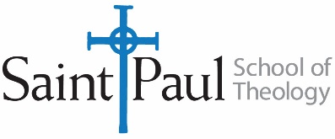 Transfer Credit Request Form

Transfer Credit Policy:
- A student or admitted applicant seeking an MACM, MATS or MDiv degree from Saint Paul must complete two-thirds of his or her work at Saint Paul. DMin students may transfer up to eight elective credit hours.
- The time limits for applying courses toward degrees—eight years for the MDiv; six years for the MACM or MATS and six years for the DMin —apply to transfer credits as well as to work taken at Saint Paul.
- Work completed at a grade of B (3.0) or above may be considered for transfer toward Saint Paul degrees. Courses with a B- or lower, pass/fail, or credit/no credit grades will not transfer.

** Please see the Saint Paul Handbook for the full Transfer Credit Policy**

Procedures for Student:
- List all courses that you wish to have evaluated with the course code, number, and title used by the transfer institution.
- Submit course descriptions, syllabi, or any other materials that convey the content of the course.
- Please make sure that the Saint Paul equivalent has been noted on the form.
- Approved courses will not be posted to your record until after you have been admitted. Check your transcripts periodically in Self- Service for confirmation.

Name: | E-Mail Address:
Degree Program:
Signature: | Date:

Name of Transfer Institution:_______________________________________________________________________

Course Code | Descriptive Title | Saint Paul Equivalent | Faculty Signature
Name of Transfer Institution:_______________________________________________________________________

Course Code | Descriptive Title | Saint Paul Equivalent | Faculty Signature

For Faculty:
Please review the attached syllabi and other supporting materials. We have verified the accreditation status of the transfer institution, that the student received at least a grade of B (3.0) and that the course was completed within our time limits.
Please return this form to the Director of Admission (for prospective students) or the Registrar (for current students) within one week.

If you have denied transfer of any credits, please indicate why the course should not be accepted here.

