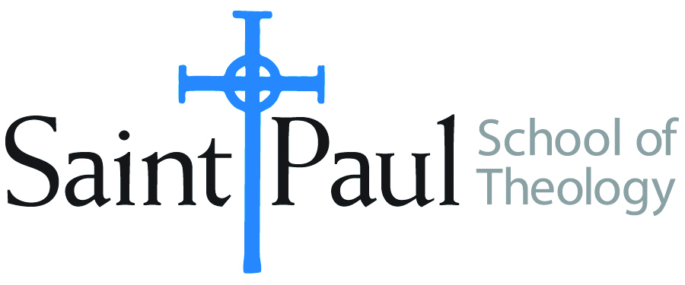 | Application for Graduation  2018-2019 Academic Year

Commencement is a joyful time! Help us to get all of the details right in advance, so that we can all celebrate to the utmost when the great day comes. Please complete and return this form to the Office of the Registrar.

Full Name:

DIPLOMA INFORMATION
- DEGREE
I am a candidate for the following degree (Check One)
MA(TS) MACM | DMin MDiv  Cert Theo Form
Specialization/Concentration:

ANTICIPATED DATE OF GRADUATION
I expect to successfully complete all course requirements for my degree by (check one):
May 17, 2019
May 18, 2019

- DIPLOMA NAME
Print or type the exact way you want your name to appear on your diploma, including commas, periods, and hyphens. We do not include titles on diplomas. Consider carefully whether you want your full name (including your middle name) to appear on your diploma, or whether you would like only the middle initial to appear. Graduate’s exact name spelling for diploma:

COMMENCEMENT ACTIVITIY
You are expected to attend commencement and the preparatory events for this exciting event.
I expect to attend commencement on (check one):
May 17, 2019 (in Kansas)
May 18, 2019 (in Oklahoma)
I cannot attend either commencement ceremony

*If you cannot attend commencement at either campus and wish to graduate in absentia, you must contact Kim Warren kim.warren@spst.edu by March 1 to make arrangements.

CURRENT CONTACT INFORMATION

Address:
Home Phone:
Cell Phone:

This is a new address and/or phone number; please change it on my academic record.

___________________________________ ___________________________
Student’s Signature Date

Please return to:
Office of the Registrar
Saint Paul School of Theology
4370 West 109th Street, Suite 300
Overland Park, KS 66211
Phone (913) 253-5050
FAX (913) 253-5075
kim.warren@spst.edu

