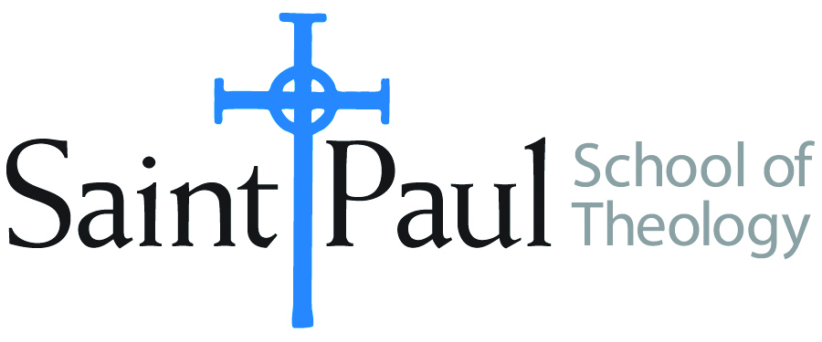
COURSE TEXTBOOK LIST INFORMATION

FACULTY INSTRUCTIONS |  |  | STUDENT INSTRUCTIONS  (Both Campuses)
For each semester taught, faculty should complete and submit a new form for every course and return to Melissa Whalen in the Academic Life office. Forms are due by the first day of registration for a given term. Desk copies for Teaching Assistants must be requested on this form. It is up to the publishers’ discretion whether or not to provide desk copies for teaching assistants. |  |  | Students may acquire textbooks by ordering online via Amazon Associate on our website and having books shipped to them. Regardless of shopping/ordering method, students may check Cokesbury online for discount on text and certain text may be sent free delivery.
COURSE INSTRUCTOR(S) | HAL KNIGHT
COURSE NUMBER & SECTION | SFR 503 AK
COURSE NAME | SPIRITUAL FORMATION
COURSE SEMESTER &YEAR | Fall 2018
DATE OF SUBMISSION

There is no Saint Paul booklist for this class. The booklist is on the Academy for Spiritual Formation website. The students are D. Min. students that are in a track linked to the Academy, and this course is linked specifically to two Academy course. They have already taken two classes like this one so they know what to do.

