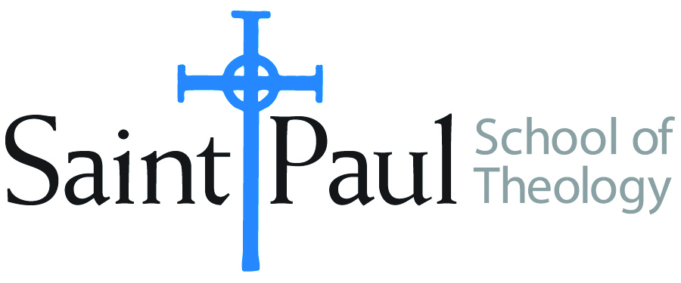
COURSE TEXTBOOK LIST INFORMATION

FACULTY INSTRUCTIONS |  |  | STUDENT INSTRUCTIONS  (Both Campuses)
For each semester taught, faculty should complete and submit a new form for every course and return to Melissa Whalen in the Academic Life office. Forms are due by the first day of registration for a given term. Desk copies for Teaching Assistants must be requested on this form. It is up to the publishers’ discretion whether or not to provide desk copies for teaching assistants. |  |  | Students may acquire textbooks by ordering online or directly from the publisher, which in some cases, the prices are more economical. Regardless of shopping/ordering method, students may check Cokesbury online for discount on text, or follow recommendations by your professor.
COURSE INSTRUCTOR(S) | Casey Sigmon
COURSE NUMBER & SECTION | PCM 312
COURSE NAME | Dinner Church Movement
COURSE SEMESTER &YEAR | Fall 2018
DATE OF SUBMISSION | March 26, 2018

REQUIRED TEXTBOOKS LIST
BOOK TITLE and EDITION  (include subtitle if applicable) |  | AUTHOR(S) | No. of  PAGES to be read | PUBLISHER and DATE | 13-Digit ISBN  (without dashes) | LIST PRICE  (estimate) | DESK COPY
1 | Weird Church: Welcome to the Twenty-First Century | Beth Ann Estock and Paul Nixon | 192 | Pilgrim Press, 2016 | 9780829820348 | 16 | YES
2
3
4
5
6
7
 | TOTAL Number of Pages to Be Read |  | 192

RECOMMENDED TEXTBOOKS LIST
BOOK TITLE and EDITION  (include subtitle if applicable) |  | AUTHOR(S) | No. of  PAGES to be read | PUBLISHER and DATE | 13-Digit ISBN  (without dashes) | LIST PRICE  (estimate) | DESK COPY
1
2
3
4

Special Instructions to Cokesbury:

