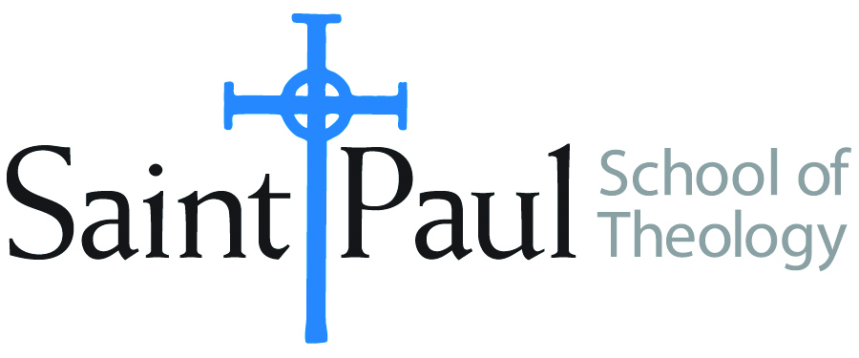
COURSE TEXTBOOK LIST INFORMATION

FACULTY INSTRUCTIONS |  |  | STUDENT INSTRUCTIONS  (Both Campuses)
For each semester taught, faculty should complete and submit a new form for every course and return to Melissa Whalen in the Academic Life office. Forms are due by the first day of registration for a given term. Desk copies for Teaching Assistants must be requested on this form. It is up to the publishers’ discretion whether or not to provide desk copies for teaching assistants. |  |  | Students may acquire textbooks by ordering online via Amazon Associate on our website and having books shipped to them. Regardless of shopping/ordering method, students may check Cokesbury online for discount on text and certain text may be sent free delivery.
COURSE INSTRUCTOR(S) | James Brandt
COURSE NUMBER & SECTION | HST 514 AKHV
COURSE NAME | Spiritual Traditions & Ministry
COURSE SEMESTER &YEAR | Fall 2018
DATE OF SUBMISSION | April 30, 2018

REQUIRED TEXTBOOKS LIST
BOOK TITLE and EDITION  (include subtitle if applicable) |  | AUTHOR(S) | No. of  PAGES to be read | PUBLISHER and DATE | 13-Digit ISBN  (without dashes) | LIST PRICE  (estimate) | DESK COPY
1 | Knowing the Context | Nieman, James R. | 180 | Fortress, 2008 | 9780800662622 | $15.00 | no
2 | The Missional Leader: Equipping Your Church to Reach a Changing World | Roxburgh, Alan J. and Fred Romanuk | 209 | Jossey-Bass,  2006 | 9780787983253 | $30.00 | no
3 | Practicing Care in Rural Congregations & Communities | Hoeft, Jeanne, L. Shannon Jung, Joretta Marshall | 173 | Fortress Press, 2013 | 9780800699543 | $12.00 | no
4 | Earthy Mysticism | Tex Sample | 104 | Abingdon, 2008 | 9780687649891 | $11.00 | no
5
6
7
 | TOTAL Number of Pages to Be Read |  | 666

RECOMMENDED TEXTBOOKS LIST
BOOK TITLE and EDITION  (include subtitle if applicable) |  | AUTHOR(S) | No. of  PAGES to be read | PUBLISHER and DATE | 13-Digit ISBN  (without dashes) | LIST PRICE  (estimate) | DESK COPY
1
2
3
4

Special Instructions to Cokesbury:

