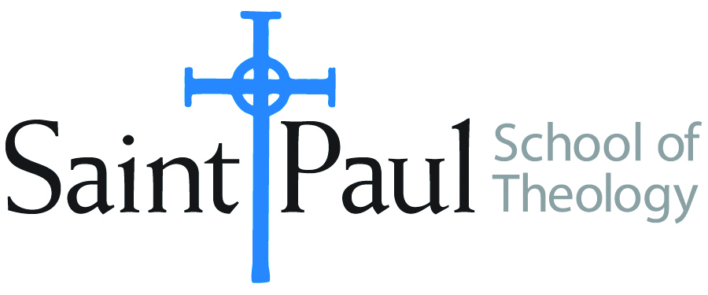
COURSE TEXTBOOK LIST INFORMATION

FACULTY INSTRUCTIONS |  |  | STUDENT INSTRUCTIONS  (Both Campuses)
For each semester taught, faculty should complete and submit a new form for every course and return to Ethel Tomlinson, Registrar Clerk/Administrative Support. Forms are due by the first day of registration for a given term. Desk copies for Teaching Assistants must be requested on this form. It is up to the publishers’ discretion whether or not to provide desk copies for teaching assistants. |  |  | Students may acquire textbooks by ordering online or directly from the publisher, which in some cases, the prices are more economical. Regardless of shopping/ordering method, students may check Cokesbury online for discount on text, or follow recommendations by your professor.
COURSE INSTRUCTOR(S) | Imad Enchassi
COURSE NUMBER & SECTION | EWR 312
COURSE NAME | Engaging World Religions: Islam
COURSE SEMESTER &YEAR | Fall 2018
DATE OF SUBMISSION | 3/26/2018

REQUIRED TEXTBOOKS LIST
BOOK TITLE and EDITION  (include subtitle if applicable) |  | AUTHOR(S) | No. of  PAGES to be read | PUBLISHER and DATE | 13-Digit ISBN  (without dashes) | LIST PRICE  (estimate) | DESK COPY
1 | Islam: The Straight Path | John L.Esposito |  | Oxford University Press, 2010 | 9780195396003 | $13
2 | What Everyone Needs to Know About Islam | John L. Esposito |  | Oxford University Press, 2011 | 9780199794133 | $8
3 | Understand Islam: A Guide for the Judeo-Christian Reader | Jerald Dirks |  | Amana Publications, 2003 | 9781590080214 | $6
4
5
6
7
 | TOTAL Number of Pages to Be Read

RECOMMENDED TEXTBOOKS LIST
BOOK TITLE and EDITION  (include subtitle if applicable) |  | AUTHOR(S) | No. of  PAGES to be read | PUBLISHER and DATE | 13-Digit ISBN  (without dashes) | LIST PRICE  (estimate) | DESK COPY
1
2
3
4

SPECIAL INSTRUCTIONS:

