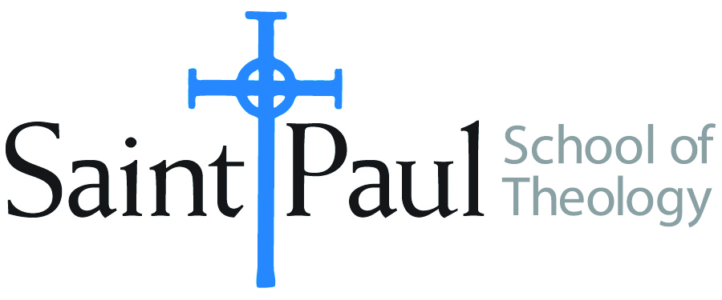
COURSE TEXTBOOK LIST INFORMATION

FACULTY INSTRUCTIONS |  |  | STUDENT INSTRUCTIONS  (Both Campuses)
For each semester taught, faculty should complete and submit a new form for every course and return to Ethel Tomlinson in the Registrar’s Office. Forms are due by the first day of registration for a given term. Faculty should request Desk copies for Teaching Assistants on this form. It is up to the publishers’ discretion whether or not to provide desk copies for teaching assistants. |  |  | Students may acquire textbooks by ordering online or directly from the publisher, which in some cases, the prices are more economical. Regardless of shopping/ordering method, students may check Cokesbury online for discount on text, or follow recommendations by your professor.
COURSE INSTRUCTOR(S) | Angela D. Sims
COURSE NUMBER & SECTION | ETH 301 AKE
COURSE NAME | Introduction to Christian Ethics
COURSE SEMESTER &YEAR | Fall 2018
DATE OF SUBMISSION | 26 March 2018

REQUIRED TEXTBOOKS LIST
BOOK TITLE and EDITION  (include subtitle if applicable) |  | AUTHOR(S) | No. of  PAGES to be read | PUBLISHER and DATE | 13-Digit ISBN  (without dashes) | LIST PRICE  (estimate) | DESK COPY
1 | The Nicomachean Ethics | Aristotle, translated by David Ross | 170 | Oxford University Press, 2016 | 9781420953640 | 8.00
2 | Social Principles of The United Methodist Church 2017-2020 | United Methodist Publishing House | 70 | United Methodist Publishing House, 2017 | 9781501835773 | 4.00 | X
3
4
5
6
7
 | TOTAL Number of Pages to Be Read

RECOMMENDED TEXTBOOKS LIST
BOOK TITLE and EDITION  (include subtitle if applicable) |  | AUTHOR(S) | No. of  PAGES to be read | PUBLISHER and DATE | 13-Digit ISBN  (without dashes) | LIST PRICE  (estimate) | DESK COPY
1
2
3
4

Special Instructions to Cokesbury:

