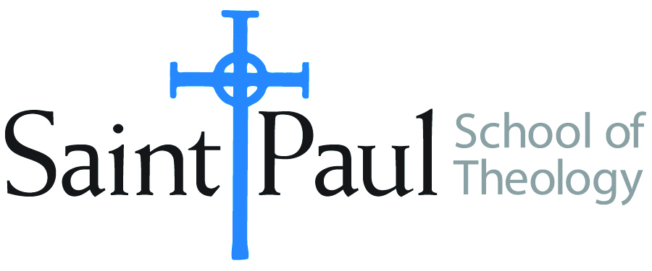
COURSE TEXTBOOK LIST INFORMATION

FACULTY INSTRUCTIONS |  |  | STUDENT INSTRUCTIONS  (Both Campuses)
For each semester taught, faculty should complete and submit a new form for every course and return to Melissa Whalen in the Academic Life office. Forms are due by the first day of registration for a given term. Desk copies for Teaching Assistants must be requested on this form. It is up to the publishers’ discretion whether or not to provide desk copies for teaching assistants. |  |  | Students may acquire textbooks by ordering online or directly from the publisher, which in some cases, the prices are more economical. Regardless of shopping/ordering method, students may check Cokesbury online for discount on text, or follow recommendations by your professor.
COURSE INSTRUCTOR(S) | James Brandt
COURSE NUMBER & SECTION | DMin 540 AKHV
COURSE NAME | Pre-Praxis Thesis Evaluation
COURSE SEMESTER &YEAR | Fall 2018
DATE OF SUBMISSION | April 30, 2018

REQUIRED TEXTBOOKS LIST
BOOK TITLE and EDITION  (include subtitle if applicable) |  | AUTHOR(S) | No. of  PAGES to be read | PUBLISHER and DATE | 13-Digit ISBN  (without dashes) | LIST PRICE  (estimate) | DESK COPY
1 | The Soul of the Congregation | Frank, Thomas Edward | 180 | Abingdon, 2000 | 9780687087174 | $15.00 | no
2 | Your Guide to Writing Quality Research Papers: For Students of Religion and Theology | Vyhmeister, Nancy Jean and Terry Dwain Robertson | 231 | Zondervan, 2014 | 9780310274407
3
4
5
6
7
 | TOTAL Number of Pages to Be Read |  | 411

RECOMMENDED TEXTBOOKS LIST
BOOK TITLE and EDITION  (include subtitle if applicable) |  | AUTHOR(S) | No. of  PAGES to be read | PUBLISHER and DATE | 13-Digit ISBN  (without dashes) | LIST PRICE  (estimate) | DESK COPY
1
2
3
4

Special Instructions to Cokesbury:

