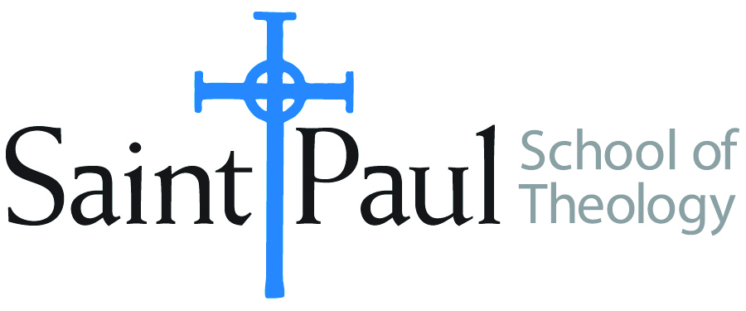
COURSE TEXTBOOK LIST INFORMATION

FACULTY INSTRUCTIONS |  |  | STUDENT INSTRUCTIONS  (Both Campuses)
For each semester taught, faculty should complete and submit a new form for every course and return to Ethel Tomlinson in the Registrar’s Office. Forms are due by the first day of registration for a given term. Faculty should request Desk copies for Teaching Assistants on this form. It is up to the publishers’ discretion whether or not to provide desk copies for teaching assistants. |  |  | Students may acquire textbooks by ordering online or directly from the publisher, which in some cases, the prices are more economical. Regardless of shopping/ordering method, students may check Cokesbury online for discount on text, or follow recommendations by your professor.
COURSE INSTRUCTOR(S) | Lisa Wolfe
COURSE NUMBER & SECTION | HBS 301 (both in-class and online sections)
COURSE NAME | Introduction to Hebrew Bible
COURSE SEMESTER &YEAR | F18
DATE OF SUBMISSION | 3/21/18

REQUIRED TEXTBOOKS LIST
BOOK TITLE and EDITION  (include subtitle if applicable) |  | AUTHOR(S) | No. of  PAGES to be read | PUBLISHER and DATE | 13-Digit ISBN  (without dashes) | LIST PRICE  (estimate) | DESK COPY
1 | The Old Testament  A Historical and Literary Introduction to the Hebrew Scriptures: Fourth Edition | Michael D. Coogan and Cynthia R. Chapman | 608 | Oxford University Press, 2017 | 9780190608651 | $76.95 | Need one please
2 | What They Don't Tell You: A Survivor's Guide to Biblical Studies | Michael Joseph Brown | 174 | Westminster John Knox 2000 (the revised version is also acceptable) | 9780664222208 | $4.17 (Amazon, used) | No need
3 | ONE of the following scholarly study Bibles (an older version that still contains NRSV is fine):  The New Oxford Annotated Bible, New Revised Standard Version, with the Apocrypha, College  Edition  OR  The New Interpreter's Study Bible: New Revised Standard Version with the Apocrypha.  Nashville  OR  HarperCollins Study Bible: Fully Revised & Updated: New Revised Standard Version: With the Apocryphal Deuterocanonical Books: Student Edition. | Michael D. Coogan, and Marc Z. Brettler, eds.  Walter J. Harrelson, ed  Edited by Harold W. Attridge | 200 | Oxford University Press, 2010  Abingdon Press, 2003  HarperCollins, 2006 | 9780195289602  9780687278329  9780060786854 | $23.  $30.  $20. | No need
4 | A Handbook to Old Testament Exegesis | William P. Brown | 380 | Westminster John Knox Press 2007 | 9780664259938 | $35
5
6
7
 | TOTAL Number of Pages to Be Read |  | 1362

RECOMMENDED TEXTBOOKS LIST
BOOK TITLE and EDITION  (include subtitle if applicable) |  | AUTHOR(S) | No. of  PAGES to be read | PUBLISHER and DATE | 13-Digit ISBN  (without dashes) | LIST PRICE  (estimate) | DESK COPY
1
2
3
4

Special Instructions to Cokesbury:

