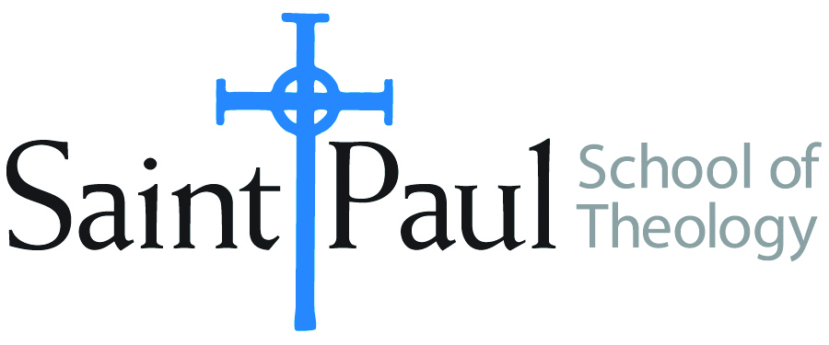
COURSE TEXTBOOK LIST INFORMATION

FACULTY INSTRUCTIONS |  |  | STUDENT INSTRUCTIONS  (Both Campuses)
For each semester taught, faculty should complete and submit a new form for every course and return to Ethel Tomlinson in the Registrar’s Office. Forms are due by the first day of registration for a given term. Faculty should request Desk copies for Teaching Assistants on this form. It is up to the publishers’ discretion whether or not to provide desk copies for teaching assistants. |  |  | Students may acquire textbooks by ordering online or directly from the publisher, which in some cases, the prices are more economical. Regardless of shopping/ordering method, students may check Cokesbury online for discount on text, or follow recommendations by your professor.
COURSE INSTRUCTOR(S) | Hal Knight
COURSE NUMBER & SECTION | DST 312
COURSE NAME | The Means of Grace in the Wesleyan Tradition
COURSE SEMESTER &YEAR | Fall, 2018
DATE OF SUBMISSION | 3-19-18

REQUIRED TEXTBOOKS LIST
BOOK TITLE and EDITION  (include subtitle if applicable) |  | AUTHOR(S) | No. of  PAGES to be read | PUBLISHER and DATE | 13-Digit ISBN  (without dashes) | LIST PRICE  (estimate) | DESK COPY
1 | John Wesley’s Sermons: An Anthology | Outler and Heirzenrater | 267 | Abingdon 1991 | 9780687204953 | $28.00
2 | United Methodist Doctrine | Scott J. Jones | 200 | Abingdon, 2002 | 9780687034857 | $26.00
3 | The Presence of God in the Christian Life | Henry H Knight III | 196 | Scarecrow 1992 | 9780810825895 | $59.95
4 | A Blueprint for Discipleship | Kevin M Watson | 115 | Discipleship Resources 2009 | 9780881775563 | $15.00
5 | Shaped by the Word | Robert M. Mulholland | 143 | Upper Room, 2001 | 9780835809368 | $12.00
6
7
 | TOTAL Number of Pages to Be Read |  | 921

RECOMMENDED TEXTBOOKS LIST
BOOK TITLE and EDITION  (include subtitle if applicable) |  | AUTHOR(S) | No. of  PAGES to be read | PUBLISHER and DATE | 13-Digit ISBN  (without dashes) | LIST PRICE  (estimate) | DESK COPY
1 | Eight Life-Enriching Practices of United Methodist | Henry H Knight III |  | Abingdon 2001 | 9780687087341 | $8.00
2 | The Means of Grace | Andrew C. Thompson |  | Seedbed, 2015 | 9781628242270 | $16.95
3 | The Class Meeting | Kevin M. Watson |  | Seedbed, 2013 | 9781628240580 | $16.95
4

