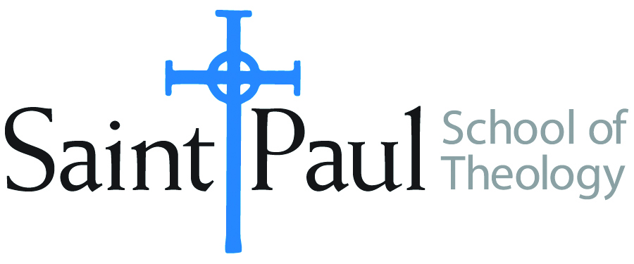
COURSE TEXTBOOK LIST INFORMATION

FACULTY INSTRUCTIONS |  |  | STUDENT INSTRUCTIONS (Both Campuses)
For each semester taught, faculty should complete and submit a new form for every course and return to Joshua Farrell in the Academic Life office. The due dates are September 1 for the following Spring and Summer, and February 1 for the following Fall and Winter. If books are needed in the bookstore at an earlier date than normal, please give exact date in the “Special Instructions” section. Due to limited space, Cokesbury may only have books on hand for the current and upcoming semesters. Desk copies for Teaching Assistants must be requested on this form. It is up to the publishers’ discretion whether or not to provide desk copies for teaching assistants. |  |  | Students may acquire textbooks by shopping at their campus Cokesbury store (in person, by email, or by fax), or by ordering online at the Cokesbury Virtual Bookstore and having books shipped to them. Regardless of shopping/ordering method, students may be eligible for a clergy discount by ordering through Cokesbury! Abingdon Press textbook titles are 35% off in the store.  Textbook lists will be available online at http://www.spst.edu/registrar/coursematerial
COURSE INSTRUCTOR(S) | Mike Graves
COURSE NUMBER & SECTION | WOR 410
COURSE NAME | Introduction to Worship and Liturgy
COURSE SEMESTER &YEAR | Spring 2018
DATE OF SUBMISSION | October 2017

REQUIRED TEXTBOOKS LIST
BOOK TITLE and EDITION  (include subtitle if applicable) |  | AUTHOR(S) | No. of  PAGES to be read | PUBLISHER and DATE | 13-Digit ISBN  (without dashes) | LIST PRICE  (estimate) | DESK COPIES
1 | Ancient Christian Worship | Andrew McGowan | 320 | Baker Academic 2014 | 9780801031526 | $25
2 | Calendar | Laurence Stookey | 190 | Abingdon 1996 | 9780687011360 | $22
3 | Table Talk | Mike Graves | 75 | Cascade 2017 | 9781532618772 | $22
4 | United Methodist Book of Worship | Andy Langford | 754 | Abingdon 1992 | 9780687035724 | $30
10 |  |  |  |  |  | $
 | TOTAL Number of Pages to Be Read |  | 415

RECOMMENDED TEXTBOOKS LIST
BOOK TITLE and EDITION  (include subtitle if applicable) |  | AUTHOR(S) | No. of  PAGES to be read | PUBLISHER and DATE | 13-Digit ISBN  (without dashes) | LIST PRICE  (estimate) | DESK COPIES
1 |  |  |  |  |  | $
2 |  |  |  |  |  | $
3 |  |  |  |  |  | $
4 |  |  |  |  |  | $
 | TOTAL Number of Pages to Be Read

Special Instructions from Faculty to Cokesbury Bookstore: Students who are not United Methodist may wish to purchase a book of worship from their own tradition.

