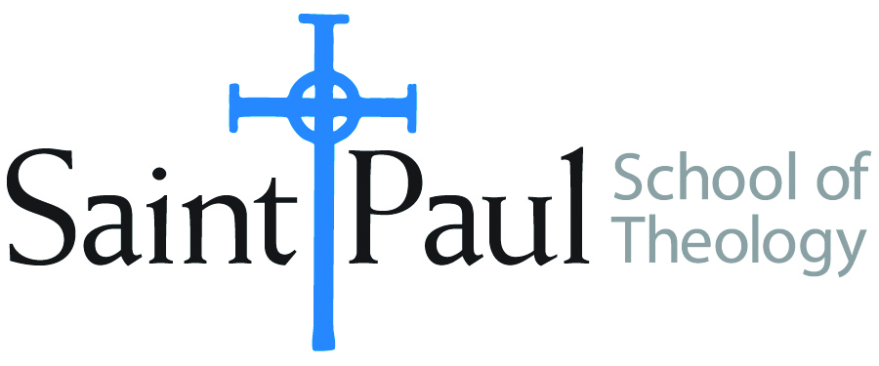
COURSE TEXTBOOK LIST INFORMATION

FACULTY INSTRUCTIONS |  |  | STUDENT INSTRUCTIONS  (Both Campuses)
For each semester taught, faculty should complete and submit a new form for every course and return to Ethel Tomlinson, Registrar Clerk/Administrative Support. Forms are due by the first day of registration for a given term. Desk copies for Teaching Assistants must be requested on this form. It is up to the publishers’ discretion whether or not to provide desk copies for teaching assistants. |  |  | Students may acquire textbooks by ordering online or directly from the publisher, which in some cases, the prices are more economical. Regardless of shopping/ordering method, students may check Cokesbury online for discount on text, or follow recommendations by your professor.
COURSE INSTRUCTOR(S) | Prof. Dr. Young-Ho Chun
COURSE NUMBER & SECTION | THL 450
COURSE NAME | The Theology of Dietrich Bonhoeffer
COURSE SEMESTER &YEAR | Spring, 2018
DATE OF SUBMISSION | October 6, 2017

REQUIRED TEXTBOOKS LIST
BOOK TITLE and EDITION  (include subtitle if applicable) |  | AUTHOR(S) | No. of  PAGES to be read | PUBLISHER and DATE | 13-Digit ISBN  (without dashes) | LIST PRICE  (estimate) | DESK COPY
1 | Discipleship | Bonhoeffer | 100 | Fortress, 2003 | 978-0800683245 | 20.98 | X
2 | Creation and Fall | “ “ | 50 | “ “ ,1997 | 978-0684825878 | 13.70 | X
3 | Christ the Center | “ “ | 50 | HarperCollins,1978 | 978-0060608118 | 10.08 | X
4 | Life Together/The prayerbook | “ “ | 80 | Fortress, 1996 | ASIN B017POX3JS | 12.00 | X
5 | Letters and Papers from Prison | “ “ | 90 | Fortress, 2010 | 978-0800697037 | 44.10 | X
 | TOTAL Number of Pages to Be Read

RECOMMENDED TEXTBOOKS LIST
BOOK TITLE and EDITION  (include subtitle if applicable) |  | AUTHOR(S) | No. of  PAGES to be read | PUBLISHER and DATE | 13-Digit ISBN  (without dashes) | LIST PRICE  (estimate) | DESK COPY
1 | Dietrich Bonhoeffer:A Brief Life | Renate Bethge | 45 | Fortress, 2004 | ASIN- B0140DBBDM | 19.99 | X
2 | Dietrich Bonhoeffer 1906-1945 | F. Schlingensiepen | 100 | C. H. Beck, 2009 (E) | 978-0567034007 | 14.14
3 | The Cambridge Companion to Dietrich Bonhoeffer | John de Gruchy, ed. | 70 | Cambridge Univ. 1999 | ASIN-B008YSKRYY | 22.00 | X
4 | Strange Glory: A Life of D. Bonhoeffer | Charles Marsh | 100 | Vintage, 2015 | 978-0307390387 | 11.72
5 | Dietrich: Bonhoeffer and the Theology of a Preaching Life | Michael Pasquarello III |  | Baylor University Press, 2017 | 978-1481307512 | 37.00

sPECIAL INSTRUCTIONS: sTUDENTS SHOULD READ nO. 1, 2, OR 4 OF THE THREE rECOMMENDED TEXTBOOKS BEFORE THE START OF THE TERM.

