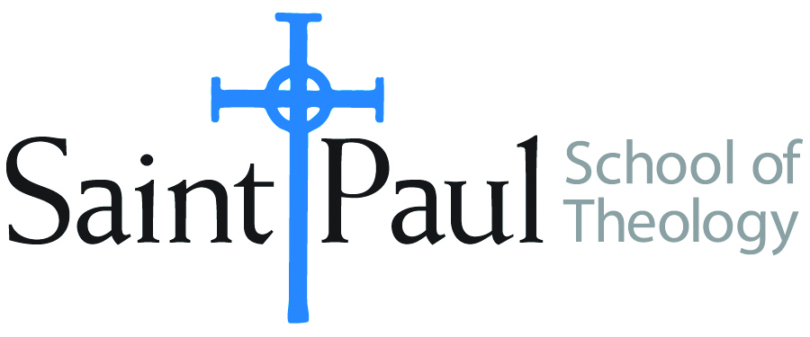
COURSE TEXTBOOK LIST INFORMATION

FACULTY INSTRUCTIONS |  |  | STUDENT INSTRUCTIONS  (Both Campuses)
For each semester taught, faculty should complete and submit a new form for every course and return to Melissa Whalen in the Academic Life office. Forms are due by the first day of registration for a given term. Desk copies for Teaching Assistants must be requested on this form. It is up to the publishers’ discretion whether or not to provide desk copies for teaching assistants. |  |  | Students may acquire textbooks by ordering online via Amazon Associate on our website and having books shipped to them. Regardless of shopping/ordering method, students may check Cokesbury online for discount on text and certain text may be sent free delivery.
COURSE INSTRUCTOR(S) | Amy Oden
COURSE NUMBER & SECTION | SFR 504
COURSE NAME | Spiritual Formation for Ministry 4
COURSE SEMESTER &YEAR | Spring 2018
DATE OF SUBMISSION | October 13, 2017

REQUIRED TEXTBOOKS LIST
BOOK TITLE and EDITION  (include subtitle if applicable) |  | AUTHOR(S) | No. of  PAGES to be read | PUBLISHER and DATE | 13-Digit ISBN  (without dashes) | LIST PRICE  (estimate) | DESK COPY
1 | The Quotidian Mysteries: Laundry, Liturgy and “Women’s Work” | Kathleen Norris | 89 | Paulist Press, 1998 | 9780809138012 | 10.00
2 | Integral Christianity: The Spirit’s Call to Evolve | Paul Smith | 408 | Paragon House, 2012 | 9781557788009 | 25.00 | x
3 | Intimacy and Mission | Luther Smith | 188 | Wipf and Stock, 2007 | 9781556355370 | 25.00 | x
4 | Disciplines of the Spirit | Howard Thurman | 128 | Friends United Press, 1963 | 9780913408353 | 15.00
5
6
7
 | TOTAL Number of Pages to Be Read

RECOMMENDED TEXTBOOKS LIST
BOOK TITLE and EDITION  (include subtitle if applicable) |  | AUTHOR(S) | No. of  PAGES to be read | PUBLISHER and DATE | 13-Digit ISBN  (without dashes) | LIST PRICE  (estimate) | DESK COPY
1
2
3
4

Special Instructions to Cokesbury:

