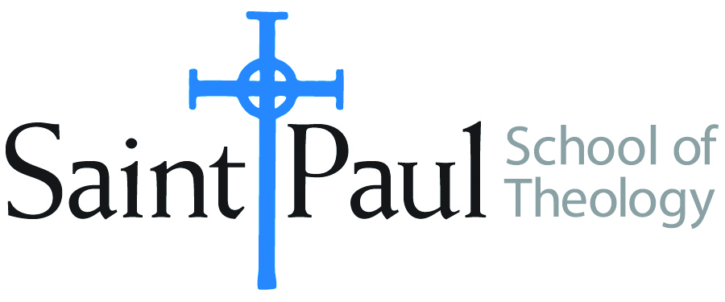
COURSE TEXTBOOK LIST INFORMATION

FACULTY INSTRUCTIONS |  |  | STUDENT INSTRUCTIONS (Both Campuses)
For each semester taught, faculty should complete and submit a new form for every course and return to Megan Temchin in the Academic Life office. Forms are due by the first day of registration for a given term. Desk copies for Teaching Assistants must be requested on this form. It is up to the publishers’ discretion whether or not to provide desk copies for teaching assistants. |  |  | Students may acquire textbooks by ordering online at the Cokesbury Virtual Bookstore and having books shipped to them. Regardless of shopping/ordering method, students may be eligible for a clergy discount by ordering through Cokesbury!  Abingdon Press textbook titles are 35% off in the store.  Textbook lists will be available online at http://www.spst.edu/registrar/coursematerial
COURSE INSTRUCTOR(S) | Dr. James Brandt & Rev. Eric Garbison
COURSE NUMBER & SECTION | PCM 351
COURSE NAME | Alternative Christian Community & Christian Witness
COURSE SEMESTER &YEAR | Spring 2018
DATE OF SUBMISSION | Oct. 15, 2017

REQUIRED TEXTBOOKS LIST
BOOK TITLE and EDITION  (include subtitle if applicable) |  | AUTHOR(S) | No. of  PAGES to be read | PUBLISHER and DATE | 13-Digit ISBN  (without dashes) | LIST PRICE  (estimate) | DESK COPY
1 | By the Rivers of Babylon: Blueprint for a Church in Exile | Robert P. Hoch | 180 | Augsburg Fortress, 2013 | 9780800698539 | $18.00 | no
2
3
4
5
6
7
 | TOTAL Number of Pages to Be Read |  | 180

RECOMMENDED TEXTBOOKS LIST
BOOK TITLE and EDITION  (include subtitle if applicable) |  | AUTHOR(S) | No. of  PAGES to be read | PUBLISHER and DATE | 13-Digit ISBN  (without dashes) | LIST PRICE  (estimate) | DESK COPY
1
2
3
4

Special Instructions to Cokesbury:

