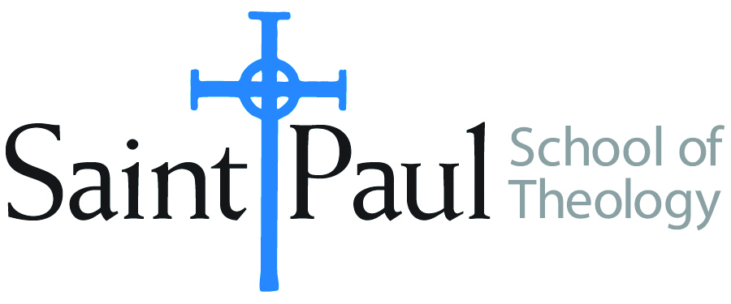
COURSE TEXTBOOK LIST INFORMATION

FACULTY INSTRUCTIONS |  |  | STUDENT INSTRUCTIONS  (Both Campuses)
For each semester taught, faculty should complete and submit a new form for every course and return to Ethel Tomlinson. Forms are due by the first day of registration for a given term. Desk copies for Teaching Assistants must be requested on this form. It is up to the publishers’ discretion whether or not to provide desk copies for teaching assistants. |  |  | Students may acquire textbooks by ordering online or directly from the publisher, which in some cases, the prices are more economical. Regardless of shopping/ordering method, students may check Cokesbury online for discount on text, or follow recommendations by your professor.
COURSE INSTRUCTOR(S) | Samantha Potter & Casey Sigmon
COURSE NUMBER & SECTION | PCM 357
COURSE NAME | Technology in Ministry
COURSE SEMESTER &YEAR | Spring 2018
DATE OF SUBMISSION | 11/13/17

REQUIRED TEXTBOOKS LIST
BOOK TITLE and EDITION  (include subtitle if applicable) |  | AUTHOR(S) | No. of  PAGES to be read | PUBLISHER and DATE | 13-Digit ISBN  (without dashes) | LIST PRICE  (estimate) | DESK COPY
1 | High-Tech Worship? Using Presentational Technologies Wisely | Quentin J. Schultze | 50 | Baker Books 2004 | 9780801064807 | $9.69
2 | The Social Media Gospel (2nd Ed) | Meredith Gould | 100 | Liturgical Press  2015 | 9780814647073 | $14.49 | X
3
4
5
6
7
 | TOTAL Number of Pages to Be Read

RECOMMENDED TEXTBOOKS LIST
BOOK TITLE and EDITION  (include subtitle if applicable) |  | AUTHOR(S) | No. of  PAGES to be read | PUBLISHER and DATE | 13-Digit ISBN  (without dashes) | LIST PRICE  (estimate) | DESK COPY
1
2
3
4

Special Instructions: Check amazon for no. 1, and Cokesbury for No. 2 Textbook (In addition, you may find lower prices at thriftstores by using google search.)

