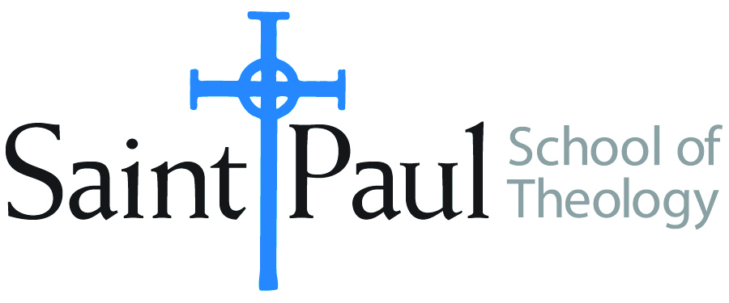
COURSE TEXTBOOK LIST INFORMATION

FACULTY INSTRUCTIONS |  |  | STUDENT INSTRUCTIONS  (Both Campuses)
For each semester taught, faculty should complete and submit a new form for every course and return to Melissa Whalen in the Academic Life office. Forms are due by the first day of registration for a given term. Desk copies for Teaching Assistants must be requested on this form. It is up to the publishers’ discretion whether or not to provide desk copies for teaching assistants. |  |  | Students may acquire textbooks by ordering online via Amazon Associate on our website and having books shipped to them. Regardless of shopping/ordering method, students may check Cokesbury online for discount on text and certain text may be sent free delivery.
COURSE INSTRUCTOR(S) | Sharon Betsworth
COURSE NUMBER & SECTION | NTS 456 Women in the New Testaments AOV
COURSE NAME | Women in the New Testament
COURSE SEMESTER &YEAR | Spring 2017
DATE OF SUBMISSION | 10/4/17

REQUIRED TEXTBOOKS LIST
BOOK TITLE and EDITION  (include subtitle if applicable) |  | AUTHOR(S) | No. of  PAGES to be read | PUBLISHER and DATE | 13-Digit ISBN  (without dashes) | LIST PRICE  (estimate) | DESK COPY
1 | Children in Early Christian Narratives (paperback) | Sharon Betsworth | Whole book | 2016 | 9780567671981 | $40 | no
2 | A Woman’s Place: House Churches in Earliest Christianity  (paperback) | Carolyn Osiek  Margaret McDonald | Whole book | 2005 | 9780800637774 | $20 | no
3 | Women’s Bible Commentary, 3rd edition (hardcover) | Ed. Jaqueline Lapsley Sharon Ringe, Carol Newsom, | @230 pages | 2012 | 9780664237073 | $35-50 | no
4
5
6
7
 | TOTAL Number of Pages to Be Read |  | Approx. 760

RECOMMENDED TEXTBOOKS LIST
BOOK TITLE and EDITION  (include subtitle if applicable) |  | AUTHOR(S) | No. of  PAGES to be read | PUBLISHER and DATE | 13-Digit ISBN  (without dashes) | LIST PRICE  (estimate) | DESK COPY
1
2
3
4

Special Instructions to Cokesbury:

