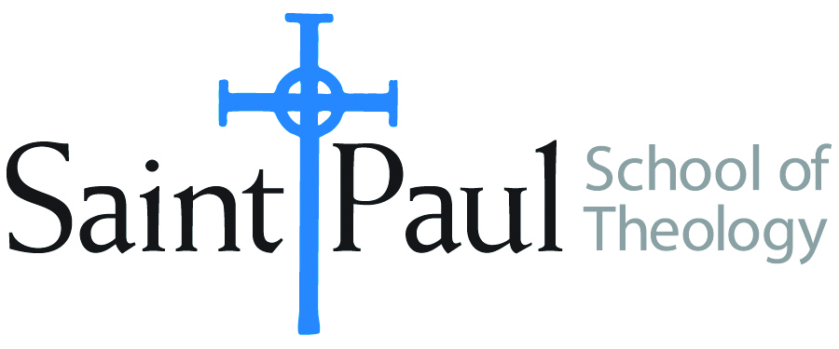
COURSE TEXTBOOK LIST INFORMATION

FACULTY INSTRUCTIONS |  |  | STUDENT INSTRUCTIONS  (Both Campuses)
For each semester taught, faculty should complete and submit a new form for every course and return to Melissa Whalen in the Academic Life office. Forms are due by the first day of registration for a given term. Desk copies for Teaching Assistants must be requested on this form. It is up to the publishers’ discretion whether or not to provide desk copies for teaching assistants. |  |  | Students may acquire textbooks by ordering online via Amazon Associate on our website and having books shipped to them. Regardless of shopping/ordering method, students may check Cokesbury online for discount on text and certain text may be sent free delivery.
COURSE INSTRUCTOR(S) | Lee Webb
COURSE NUMBER & SECTION | MIN 231 AOV
COURSE NAME | Information Literacy in Theological Education
COURSE SEMESTER &YEAR | SPRING 2018
DATE OF SUBMISSION | 10/04/17

REQUIRED TEXTBOOKS LIST
BOOK TITLE and EDITION  (include subtitle if applicable) |  | AUTHOR(S) | No. of  PAGES to be read | PUBLISHER and DATE | 13-Digit ISBN  (without dashes) | LIST PRICE  (estimate) | DESK COPY
1 | Quality Research Papers: For Students of Religion and Theology, 3rd ed. | Nancy Jean Vyhmeister and Terry Dwain Robertson | 300 | Zondervan; 2014 | 9780310514022 | $19.99
2
3
4
5
6
7
 | TOTAL Number of Pages to Be Read |  | 373

RECOMMENDED TEXTBOOKS LIST
BOOK TITLE and EDITION  (include subtitle if applicable) |  | AUTHOR(S) | No. of  PAGES to be read | PUBLISHER and DATE | 13-Digit ISBN  (without dashes) | LIST PRICE  (estimate) | DESK COPY
1 | Writing Theology Well: A Rhetoric for Theological and Biblical Writers, 2nd ed. | Lucretia Yaghjian | 73 | Bloomsbury,  2015 | 9780567499172 | $29.95
2 | From Topic to Thesis: A Guide to Theological Research | Michael Kibbe |  | IVP, 2016 | 9780830851317 | $12.00
3
4

Special Instructions to Cokesbury:

Only the sections of the Yaghjian text pertaining to research (Chapters 5&6) are used in this course, but the text is highly recommended for students who are planning to write a thesis or dissertation.

